**Mobile Computing Progress**

**Lecture 2-3: Learning VCS**

* 1. Let us start with creating a repository.
  2. Create an account on <github.com>.
  3. Now click on the **+** icon on the top right corner and then click on **New Repository** as given below to create a new repository.

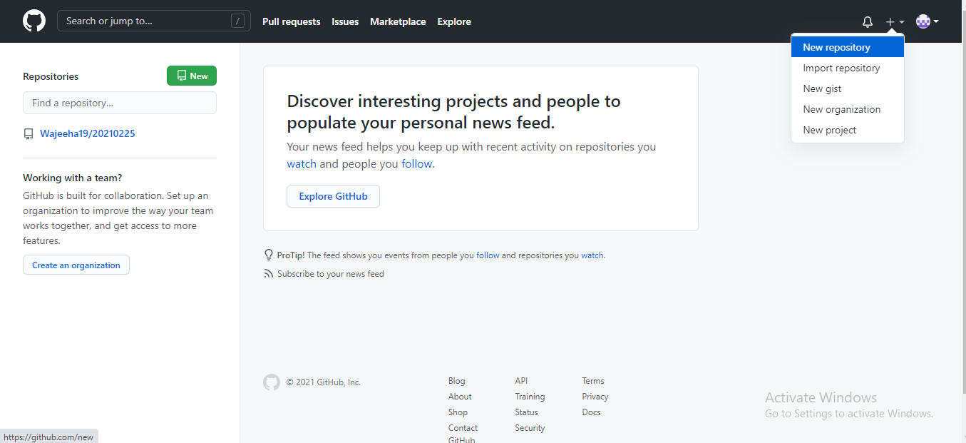

* 1. Now provide the details for your repository.

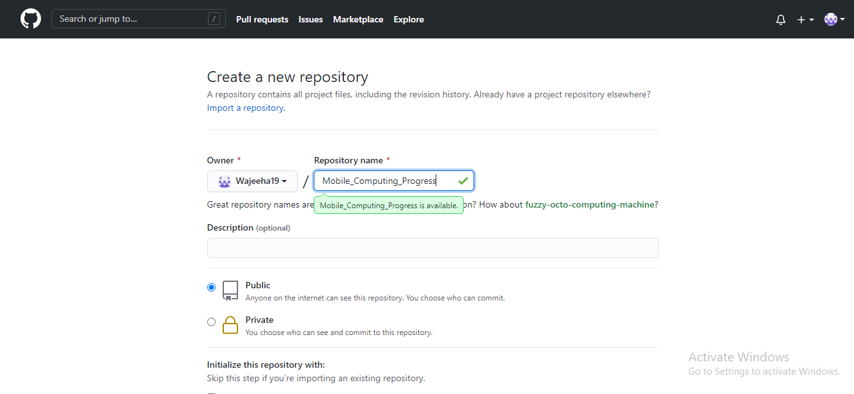

* 1. Click on the **Create Repository** button. You will be redirected to your repository home page.

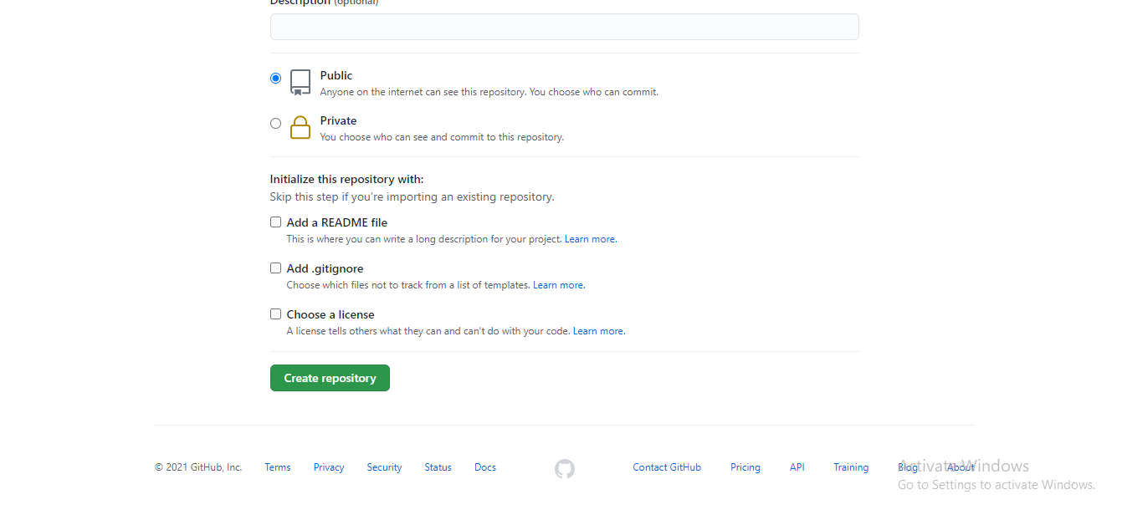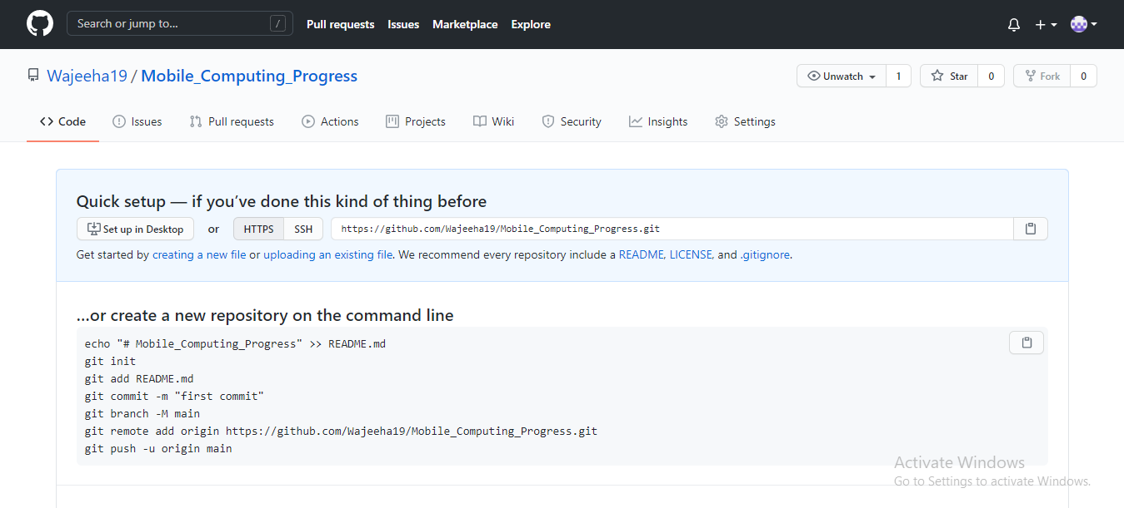

1. After creating an online repository. We must clone it, so that it can be used on your PC.
   1. 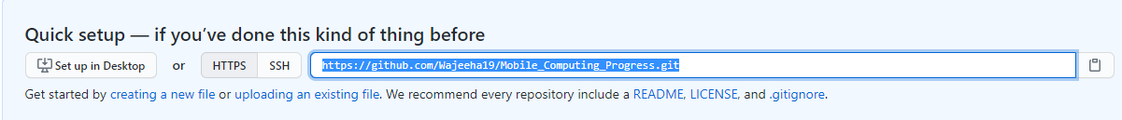Copy the repository URL. You can either copy *HTTPS* or *SSH* URL.
   2. Now open the **Git Bash** and clone your repository using **git clone repository_name.**

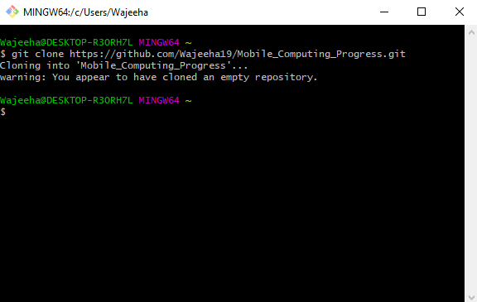

1. 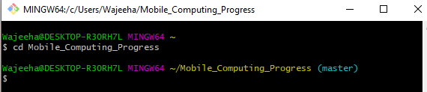Now you have the repository on your system. Let us try some git commands to understand *VCS* well
   1. Let us change the directory to your local repository.
   2. Let us create a file in local repository and add some content in it.

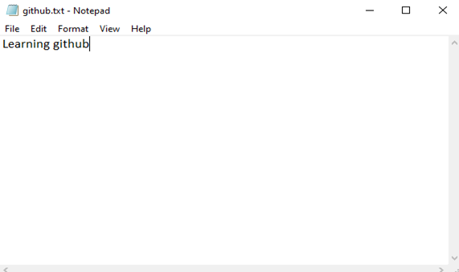

* 1. Now add the file to the local repository using command **add file_name** in bash so the that fit can track the file
  2. Now enter the git status command to see the status of file. You will see that file is added and tracked by git but it’s not yet committed to it.
  3. 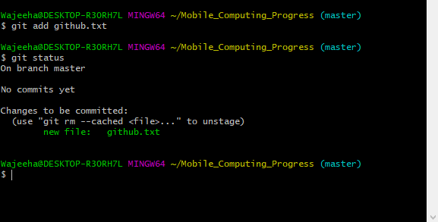To solve this issue, enter command **git commit -m “message”** to track changes. And enter git status. Now you can see that there is nothing to commit.

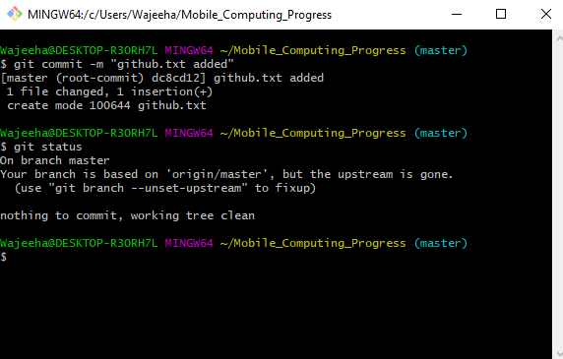

* 1. Now we have committed the changes. But still these changes are not visible in online repository. So, to see the changes to online repository enter **git push** command.

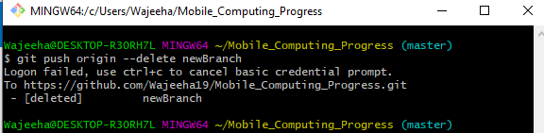

* 1. 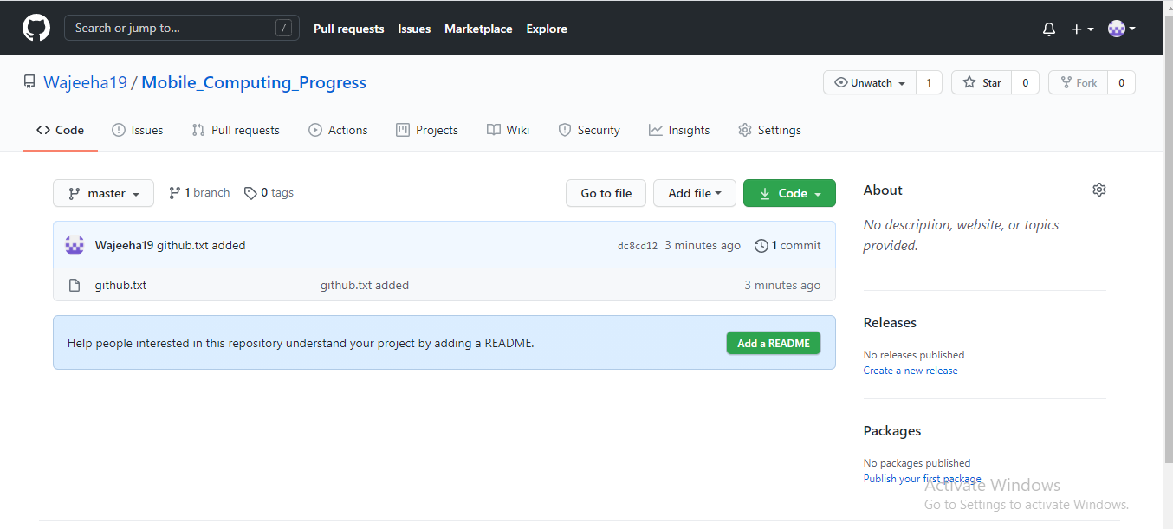Now you can see the changes in your online repository too as below.

1. Now let us see how to edit the file in online repository. Click on the edit icon as below.

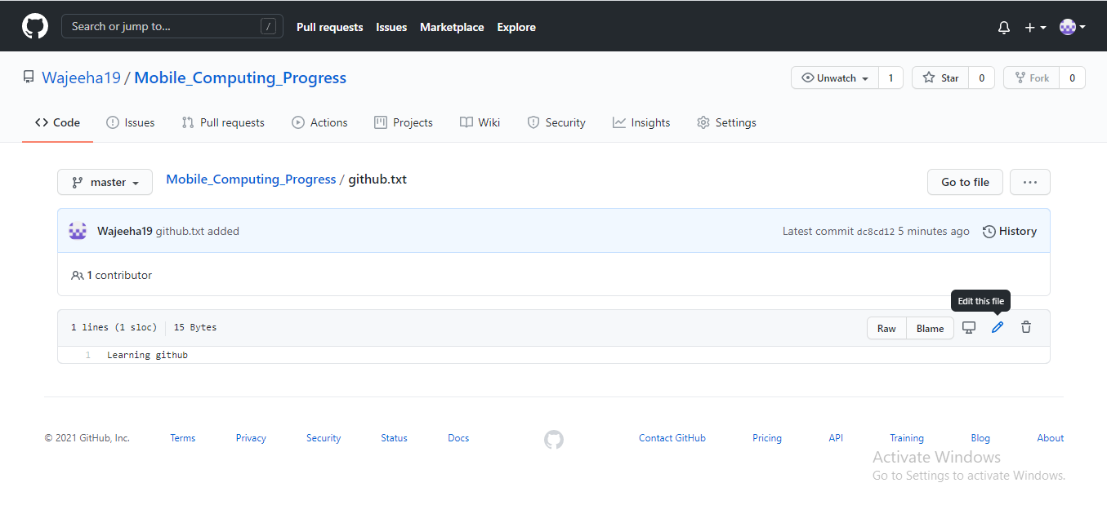

* 1. Enter the changes you want to make to the file.
  2. 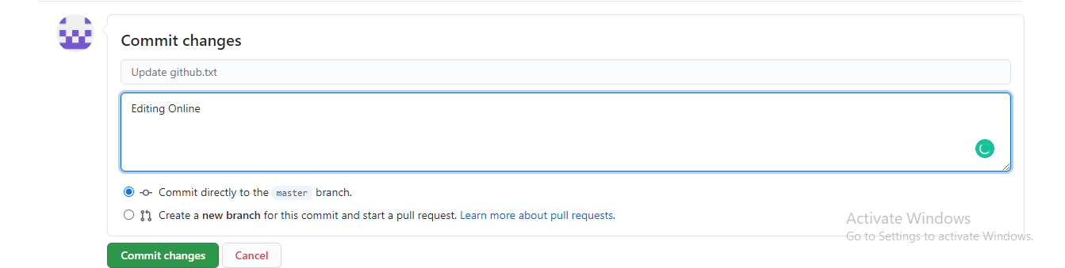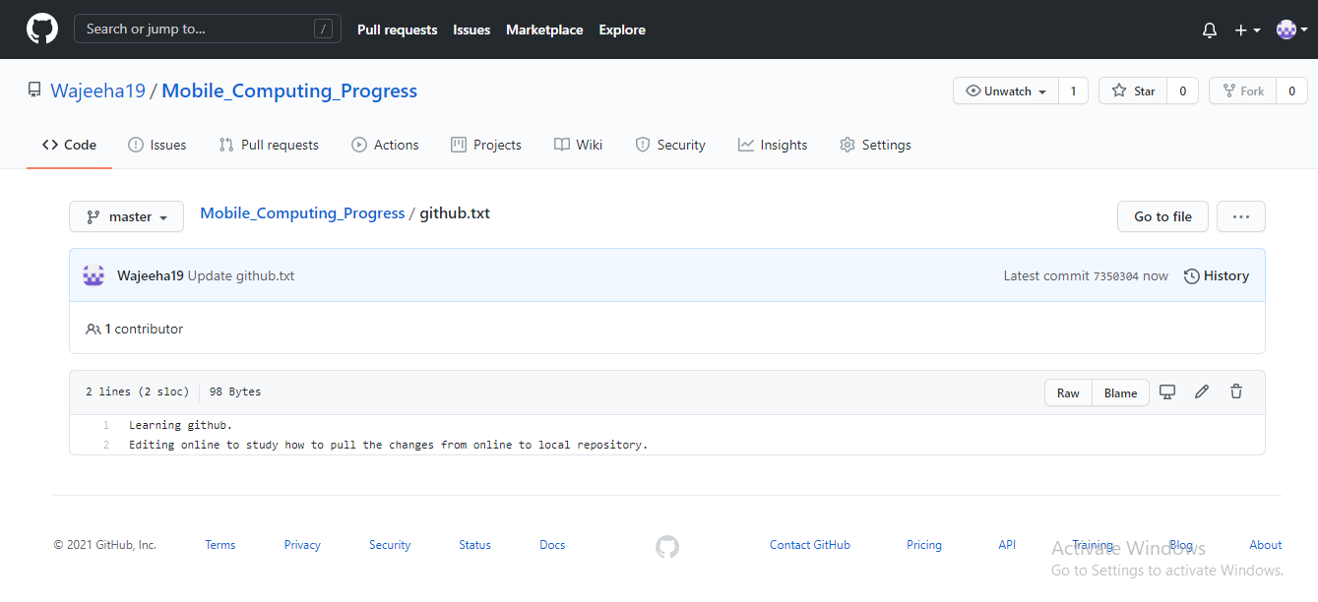Now commit the changes at online repository as below by clicking the **Commit changes** button.
  3. 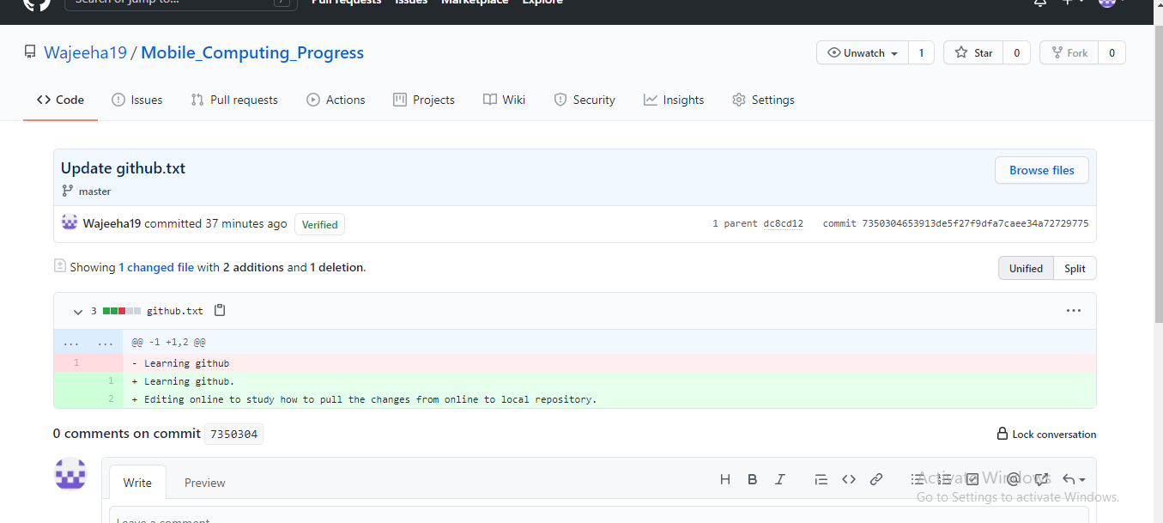Now you will see the file with latest changes on your repository homepage. You can also see the changes made to it by clicking on the file.
  4. Now to have the latest file in your local repository. Go to git bash and enter **git pull** command.
  5. 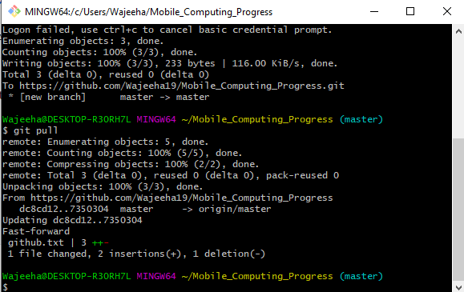 You can now see the changes in file in your local repository.

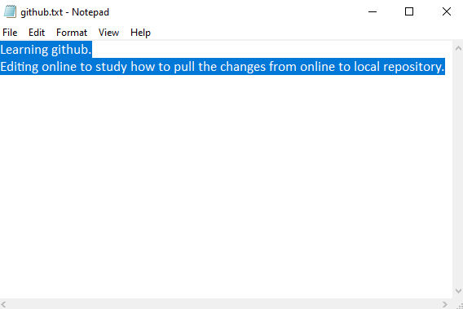

1. Let us learn branching.
   1. Create a new branch using command **git checkout -b new_branch_name.**
   2. You can check in which branch you are in by using **git branch** command

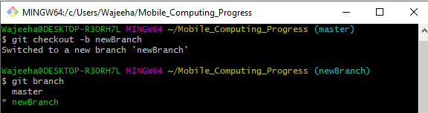

* 1. Now let us create a file and come content in it and then add and commit it to the local repository.

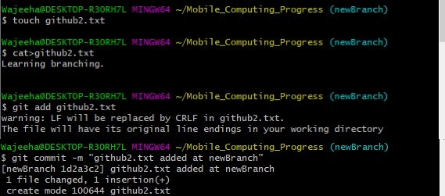

* 1. 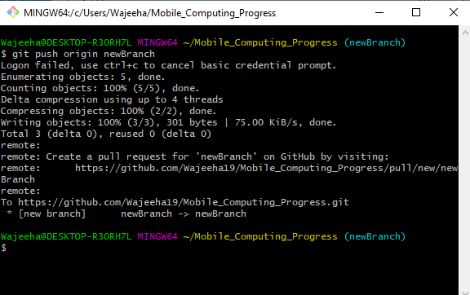Now to see changes in online repository, enter **git push -u origin new_branch_name.**
  2. Check your online repository you can see the changes that anew branch is created like below.

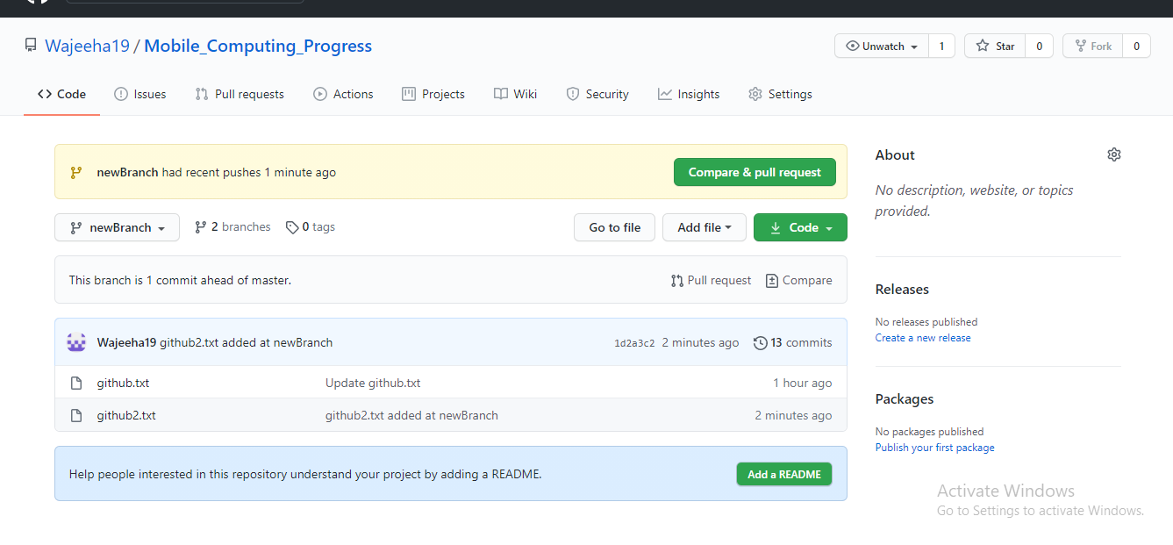

* 1. Now I want to merge both branches and their contents at master. So, I must check out to master branch using enter command **git checkout master** in bash terminal.

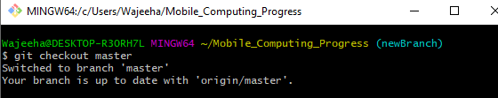

* 1. Now enter command **git merge master new_branch_name** in bash terminal to merge both the branches. After merging the branches push the changes to online repository.

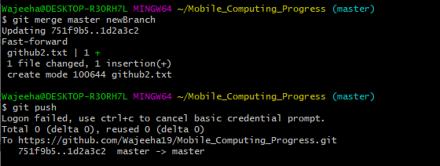

* 1. Now let us delete the newly created branch using **git push origin –delete new_branch_name** in Git Bash terminal to remove the newly created branch in both local and online repository.



* 1. Now you can see changes in the online repository that only one branch is remained, and it contains both the files.

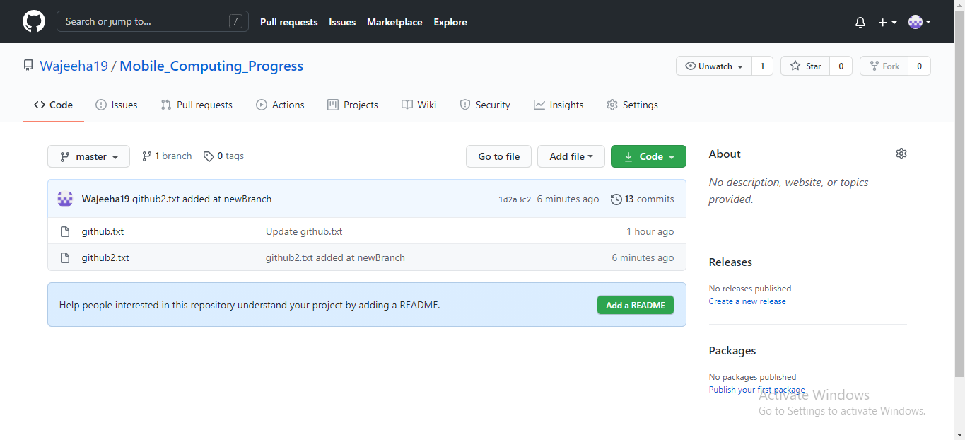

**Lecture 4: Creating simple Mobile App to Understand Constraint Layout.**

1. Open **Android Studio** first and create a Project by selecting an ***Empty Activity*** as follows.

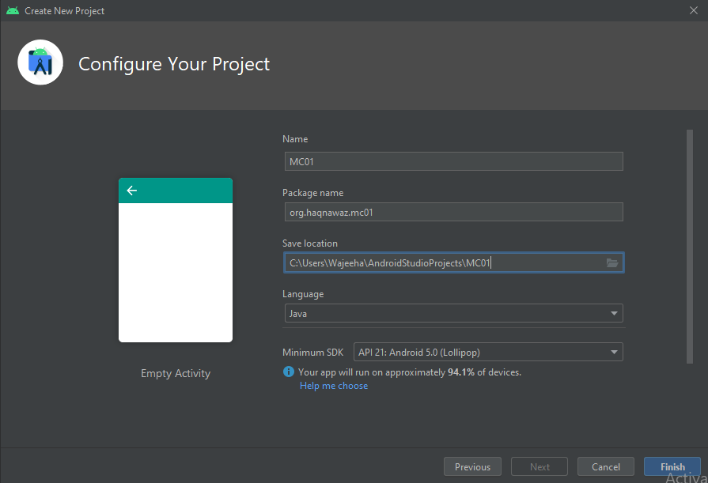

1. Now in Android View of your project open **activity_main.xml** present in app->res->layout and start putting the necessary thing from **Palette** section and adjusting the constraints as follows.
   1. Add ***TextView*** in *Text* category from Palette section and adjust the constraints.
   2. Add ***Plain Text*** in *Text* category from Palette section and adjust the constraints.
   3. Add ***Password*** in *Text* category from Palette section and adjust the constraints.
   4. Add ***Button*** in *Button* category from Palette section and adjust the constraints.

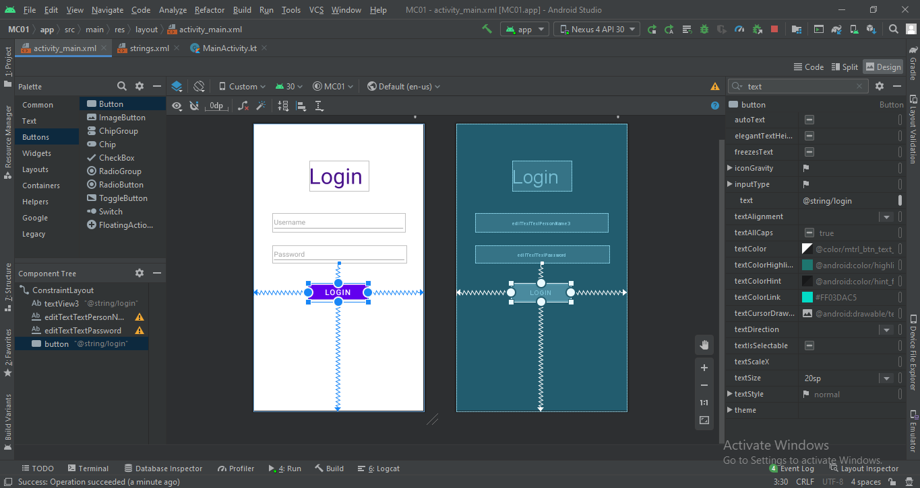

1. 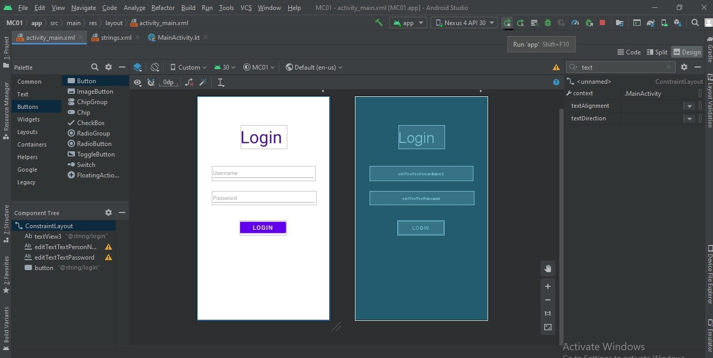Now run the project by clicking the run icon as shown
2. 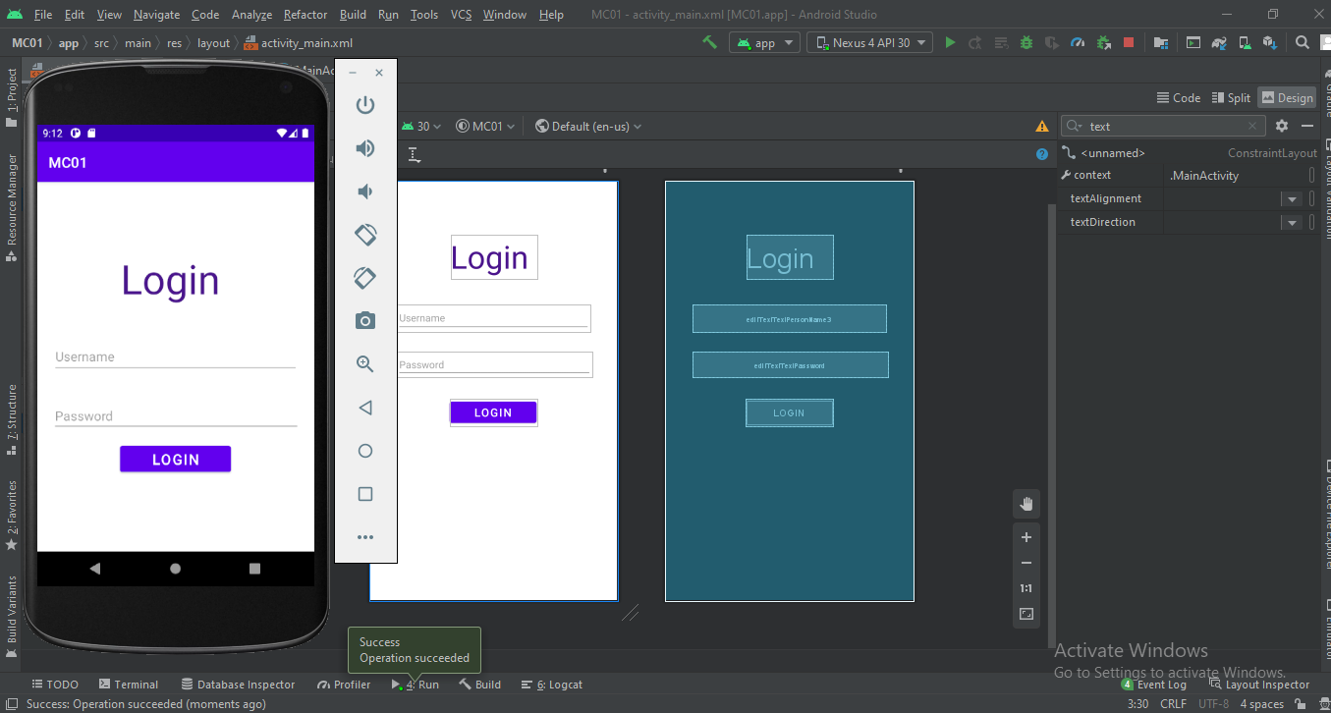On running project, we’ll get the desired screen as follows.

**Lecture 5: Learning About Buttons**

1. Open **Android Studio** first and create a Project by selecting an ***Empty Activity***.
2. Now add a ***TextView*** and a ***Button*** in your **activity_main.xml** as follows.

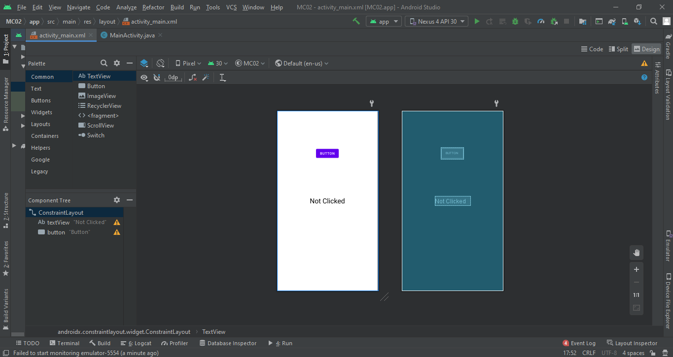

1. Now in **activity_main.xml Code View** write property of button click as follows**.**

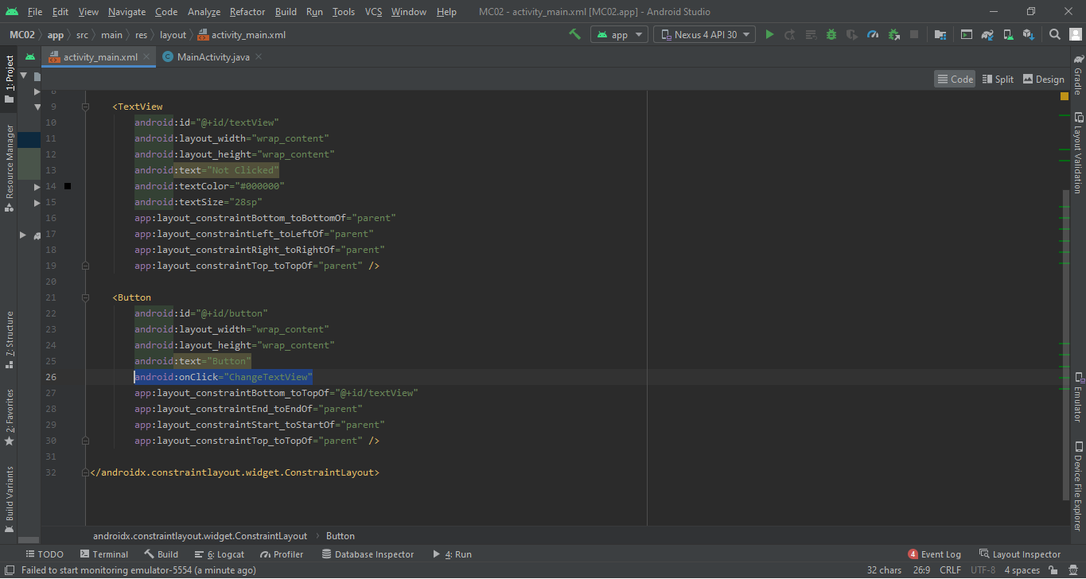

1. Now write the onclick function definition in **MainActivity.java** as follows**.**

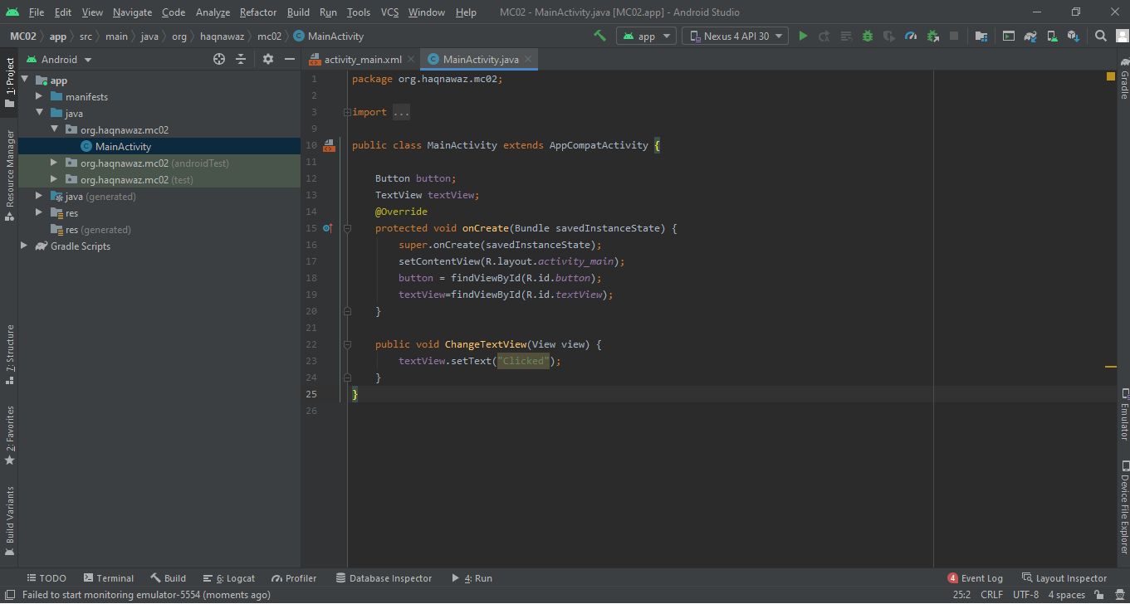

1. Lets run the project to get the desired results.

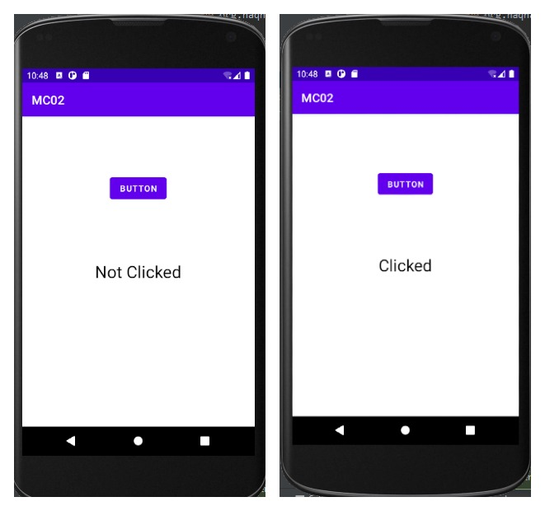

**Lecture 6: Learning Activities and Intents**

An **Activity** is an application component. It represents one window, one hierarchy of views.

An **Intent** is a description of an operation to be performed. An Intent is an object used to request an

action from another app component via the Android system.

1. Open **Android Studio** first and create a Project by selecting an ***Empty Activity***.
2. After creating a project add another activity in project as follows.

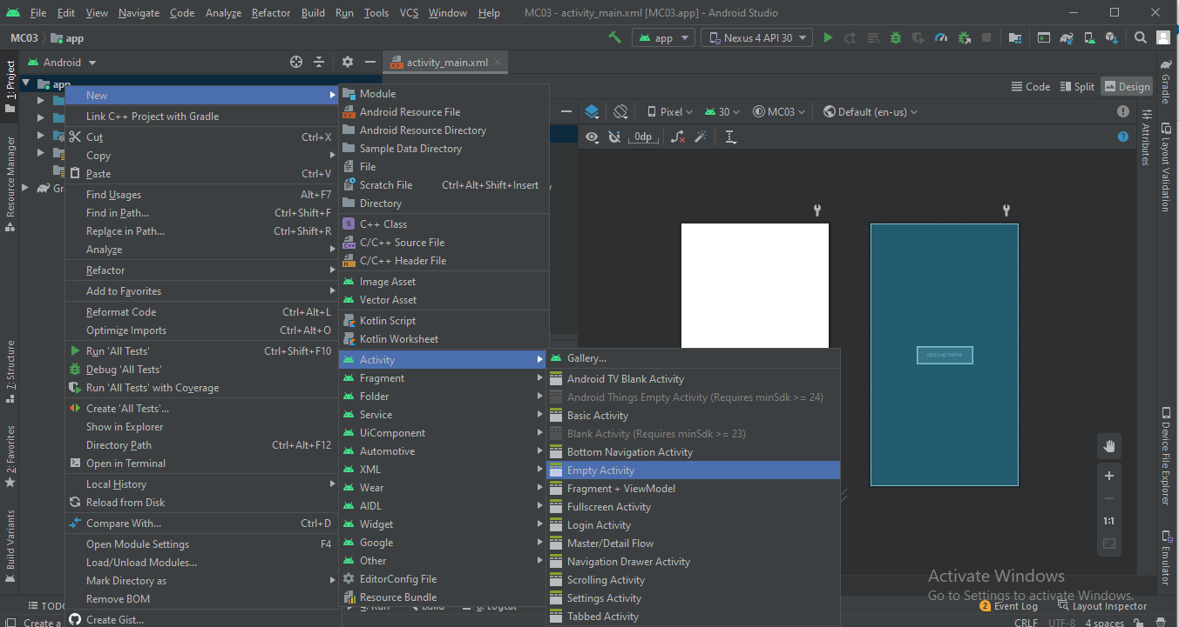

1. Now add a ***TextView*** and a ***Button*** in your **activity_main.xml** as follows.

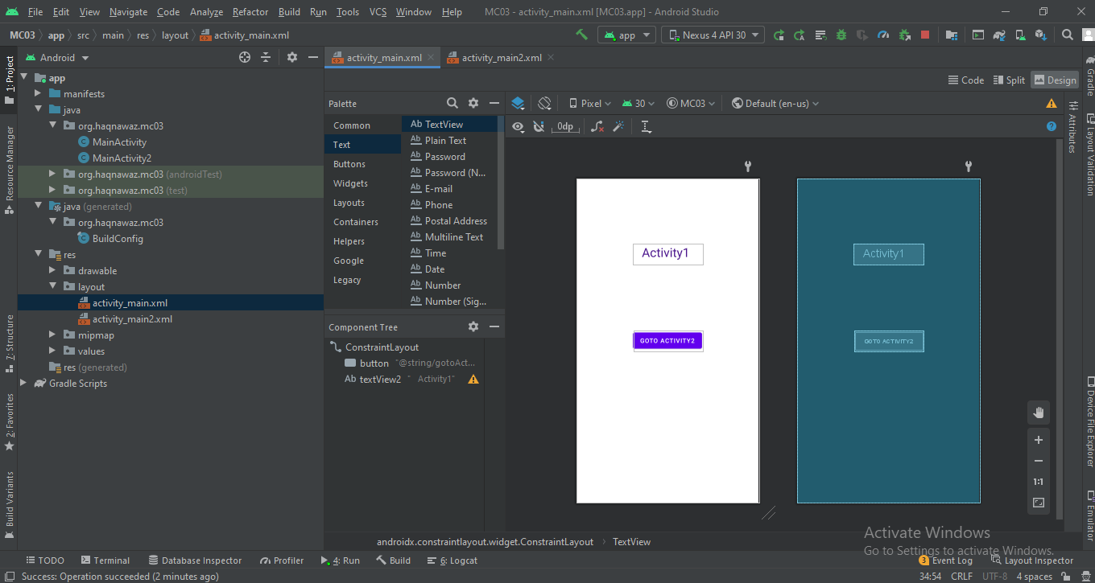

1. Now add a ***TextView*** and two ***Button*** in your **activity_main2.xml** as follows.

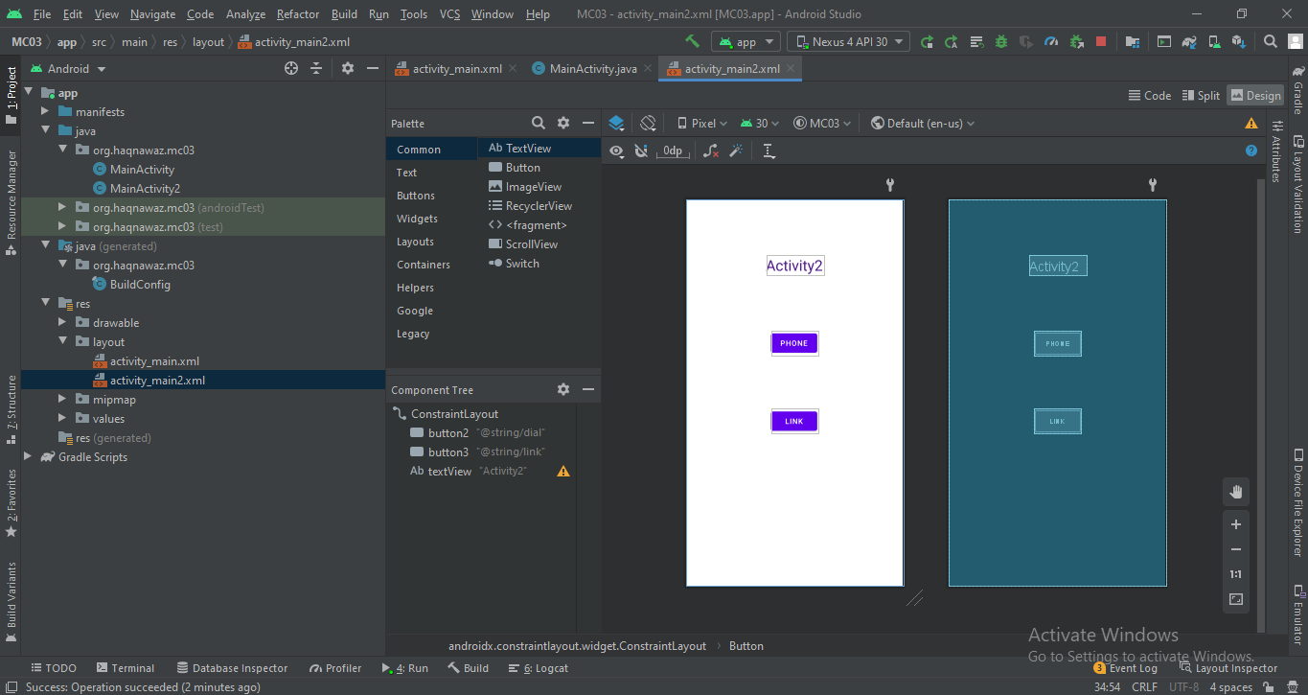

1. Now to move from **Main Activity** to **Main Activity2**  we need to code as follows.

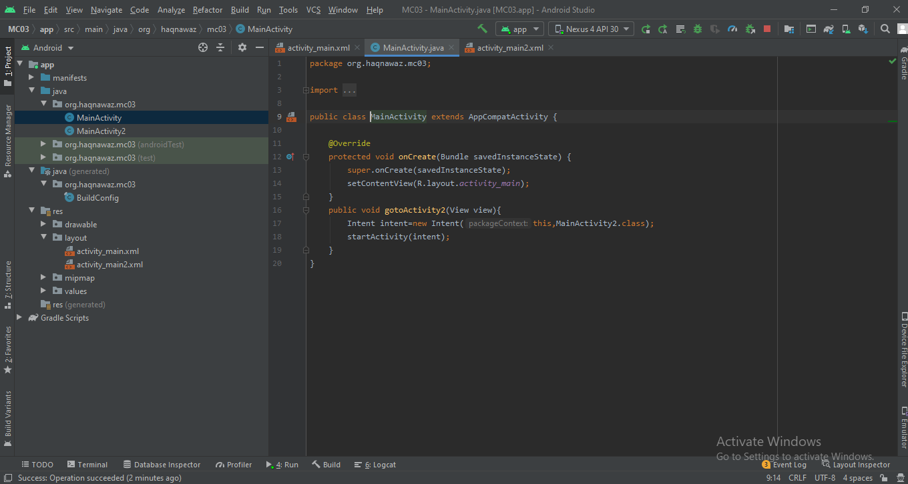

1. Now let’s code to open dialer on ***Phone*** button click and open browser on ***Link*** button click from MainActivity2 as follows.

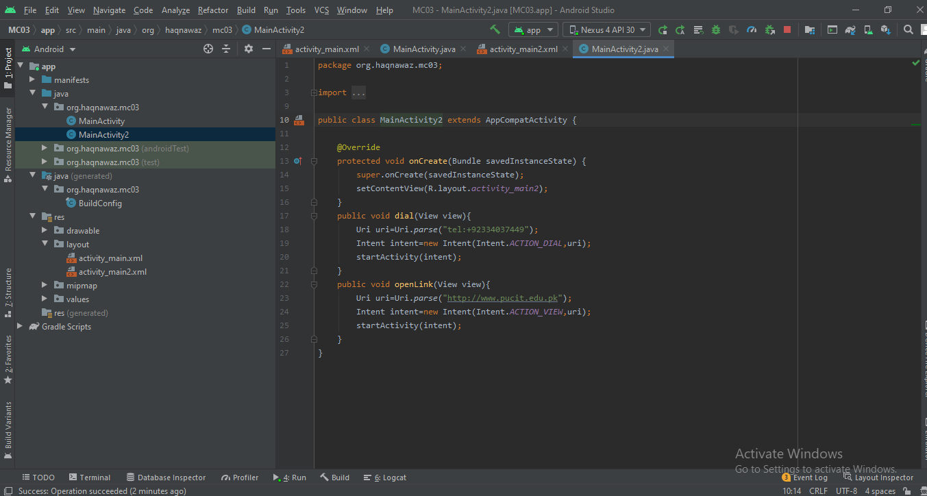

1. Lets run the project to get the desired results.

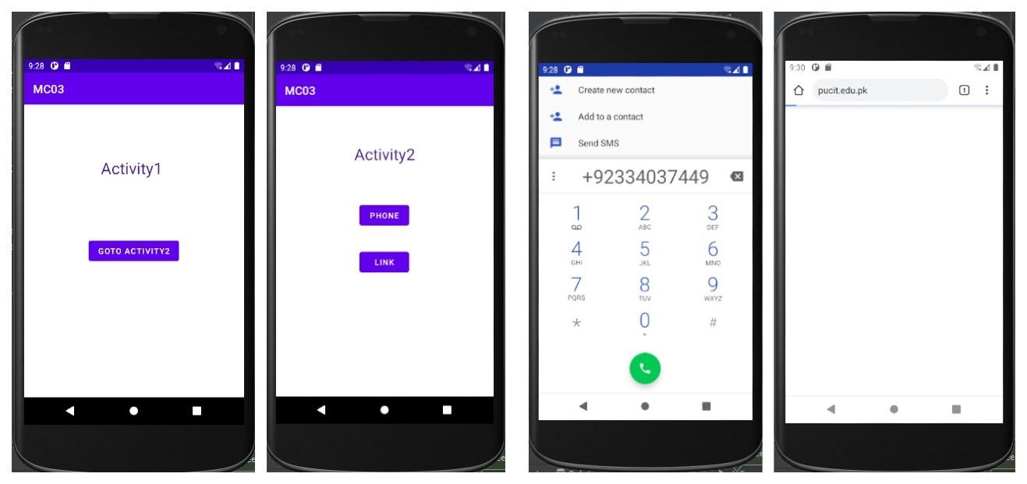

**Lecture 7: Learning About States By Creating a Counter App**

1. Open **Android Studio** first and create a Project by selecting an ***Empty Activity***.
2. Now add **LinearLayout,** two ***TextView*** *for counter* and a ***Button*** *to* *increment counter* in your **activity_main.xml** as follows.

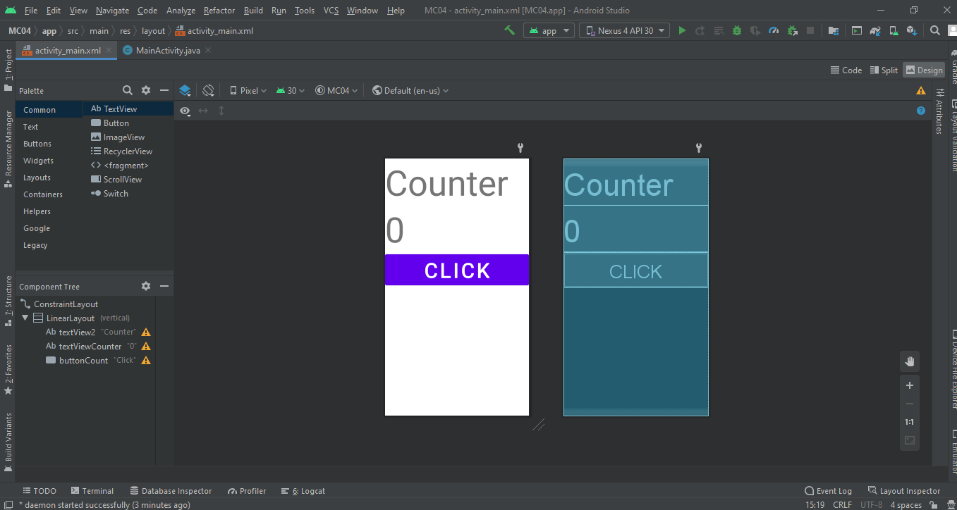

1. Now in **MainActivity.java** write code to increment and display incremented counter as follows**.**

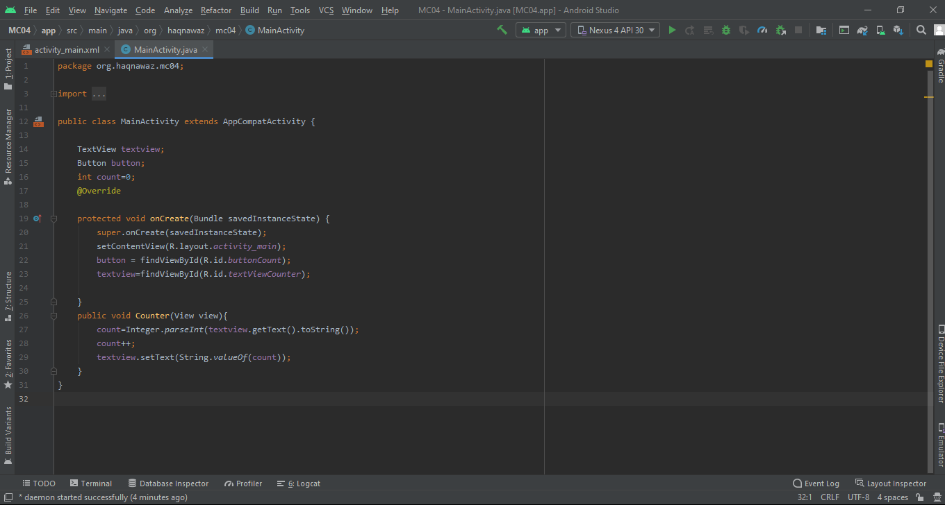

1. Now run the project to see if the code is working fine. You will see that counter is getting incremented correctly but when we rotate screen the counter value gets back to zero as follows.
2. Now lets see whether this problem also exits when we move from one activity to another.
   1. For this lets create two activities.
   2. Now add two ***Button*** in **activity_main.xml** one for *activity2* and other for *activity3* as follows.

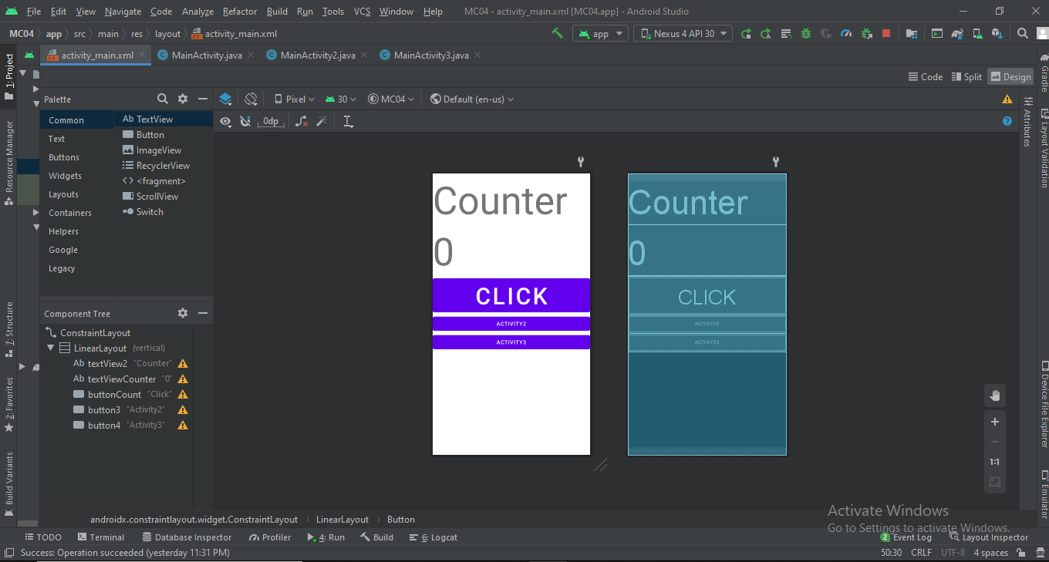

* 1. Now add **LinearLayout,** a ***TextView*** and a ***Button*** in **activity_main2.xml** as follows.

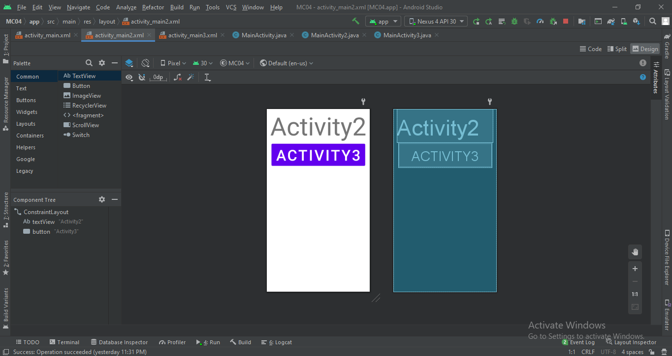

* 1. Add **LinearLayout** and a ***TextView*** in **activity_main3.xml** as follows.

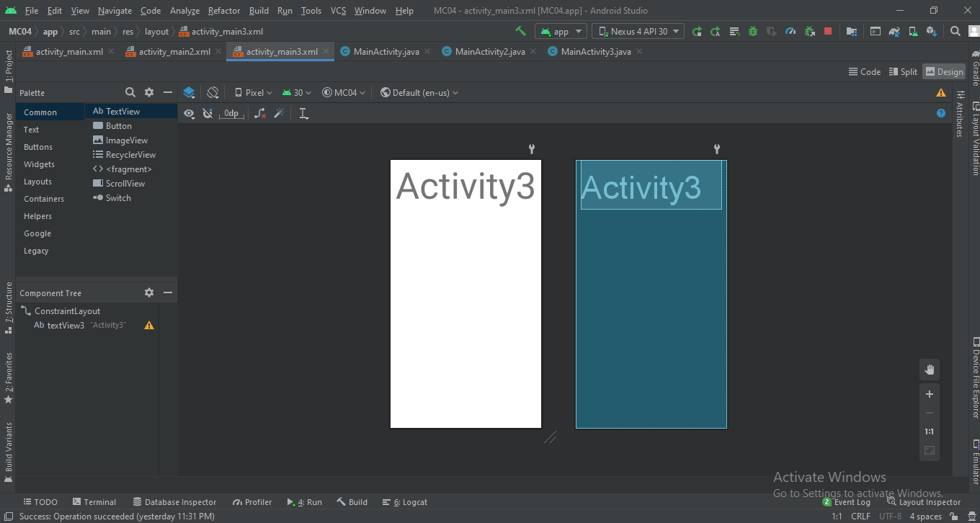

* 1. Now add the code to **MainActivity.java** as follows.

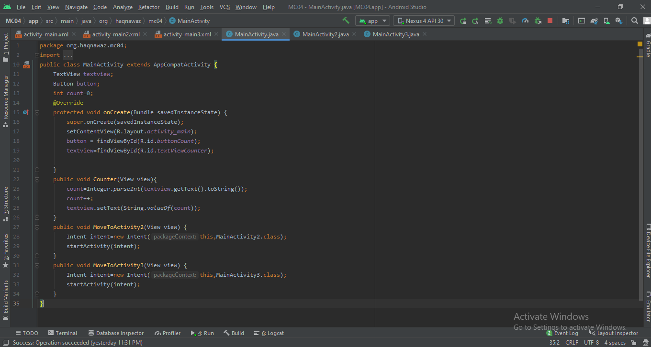

* 1. Add the code to **MainActivity2.java** as follows.

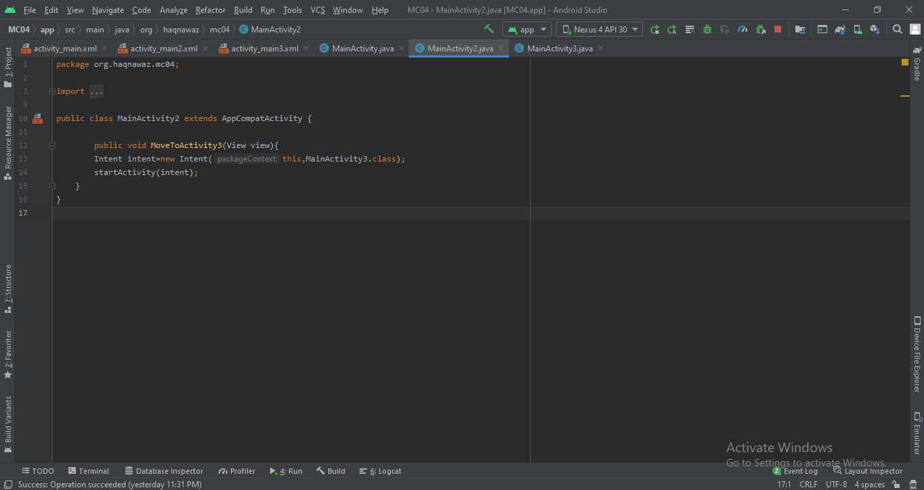

* 1. Add the code to **MainActivity3.java** as follows.

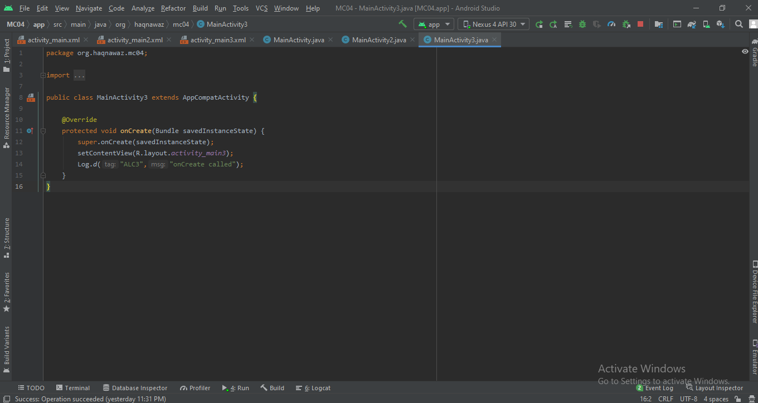

* 1. Now run the project to see if the same problem exits or not. You will see that on changing activity counter value gets back to **0** as follows.

1. To solve this problem we need to save the state.
   1. Add the following code to **MainActivity.java.**

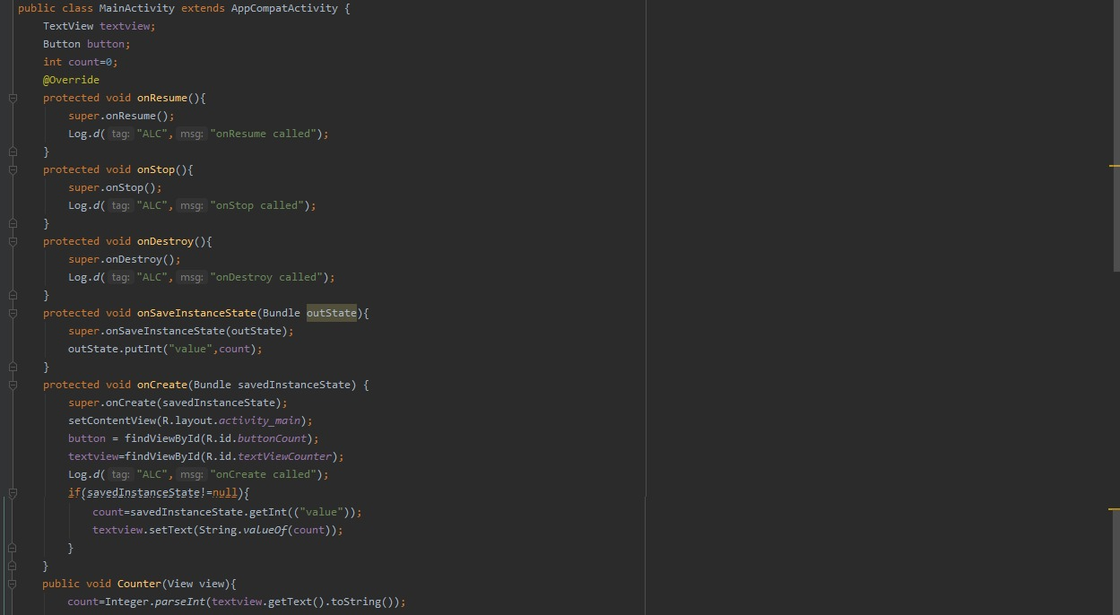

* 1. Now let’s run the project to get the desired results.

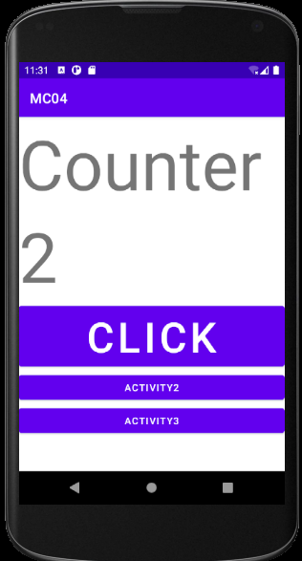

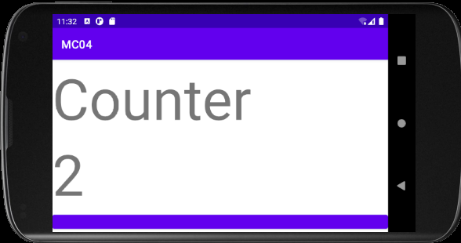

1. Now lets save the state on changing activity as well.
   1. Add the following code to **MainActivity2.java.**

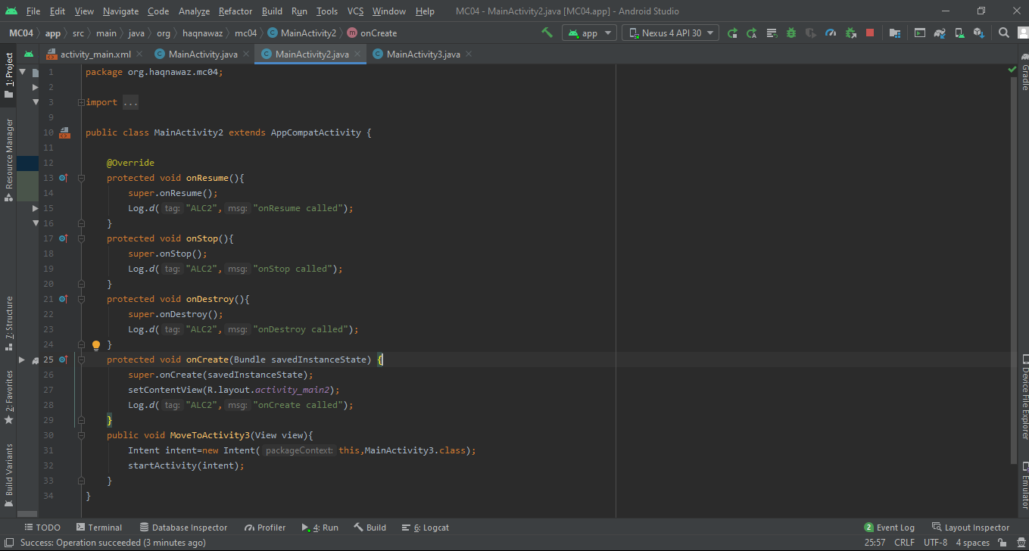

* 1. Add the following code to **MainActivity3.java.**

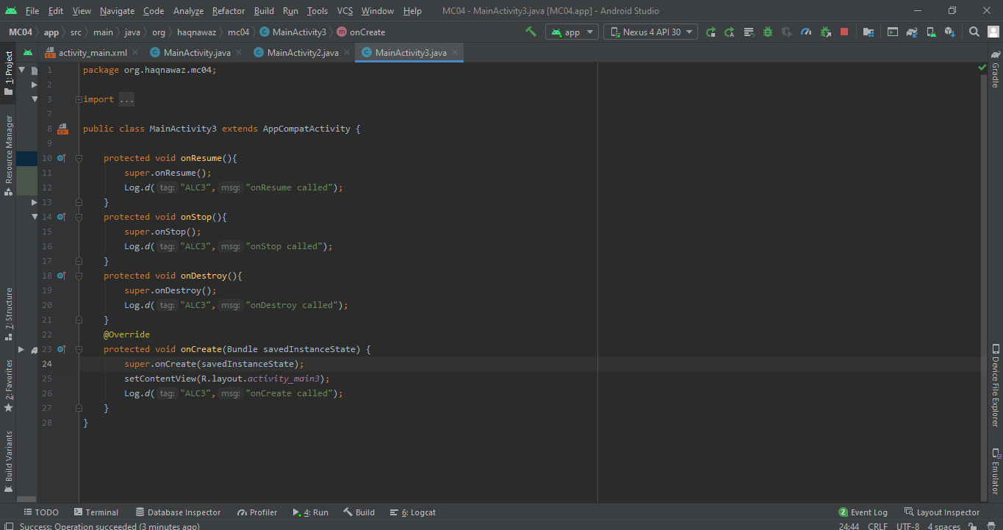



* 1. Now let’s run the project to get the desired results.



**Lecture 09: Learning Animations**

### Step 1: Add animation in App.

#### Step 1.1: Create a new project.

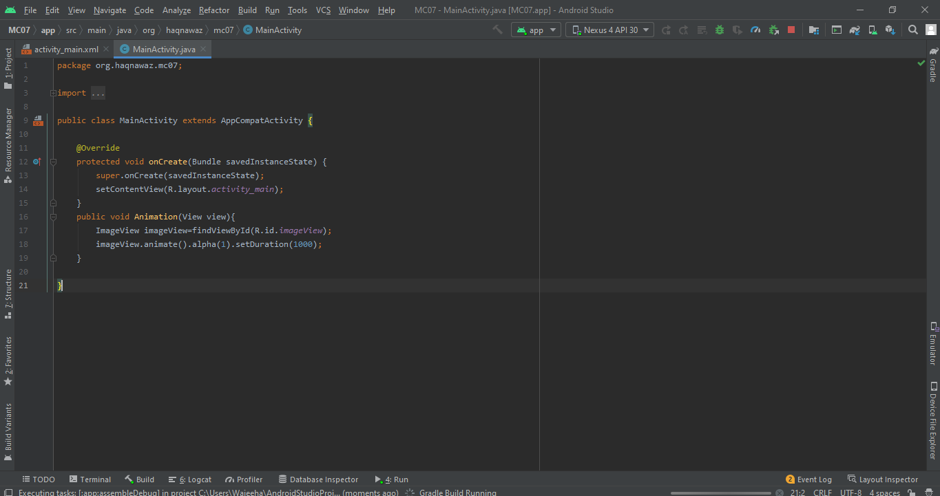

#### Step 1.2: In activity_main.xml add an **ImageView.**

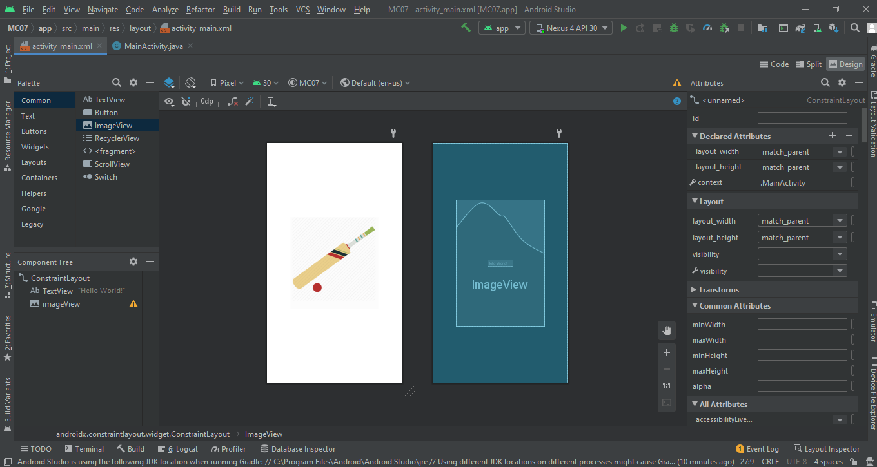

* 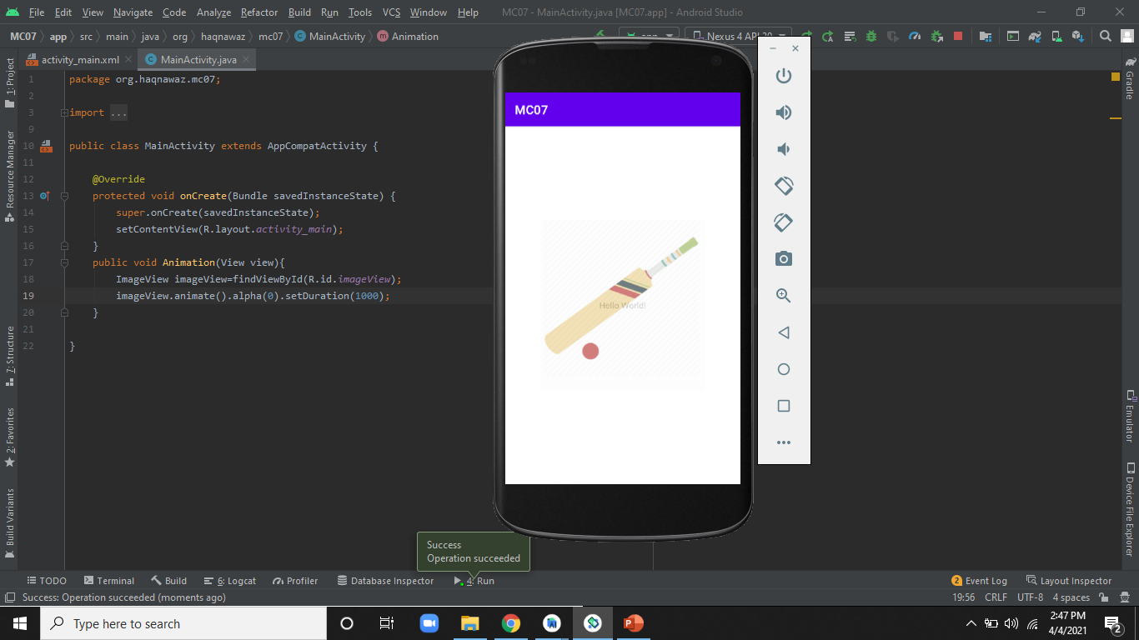Step 1.3: Now apply different animations and run

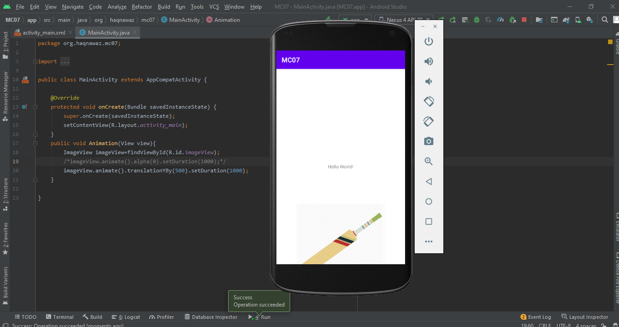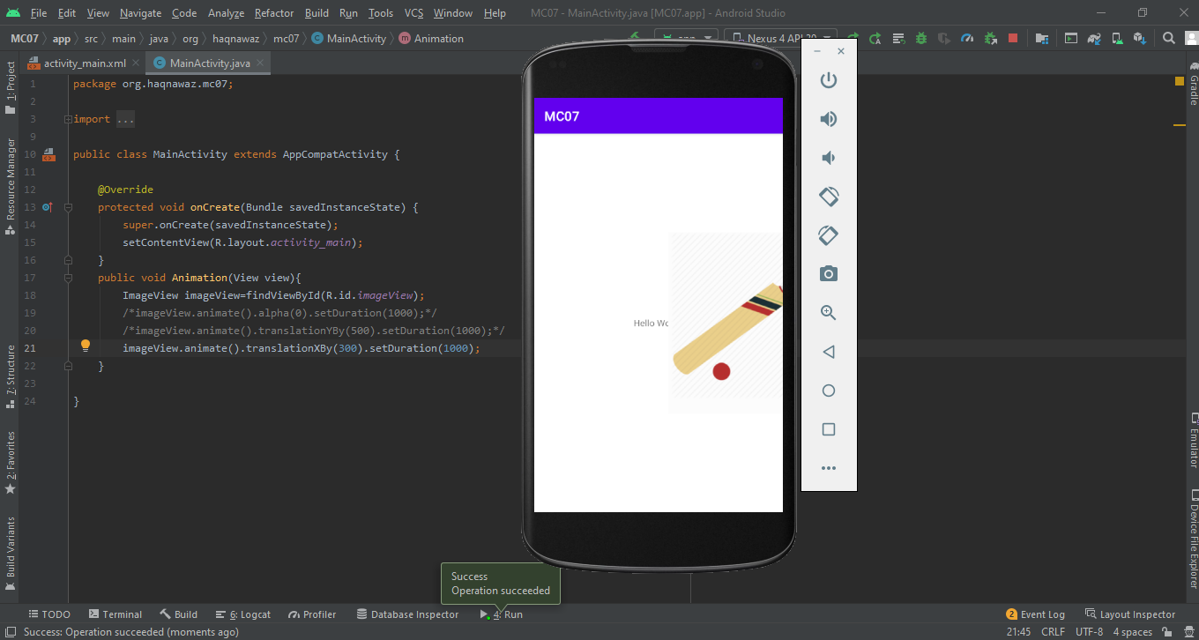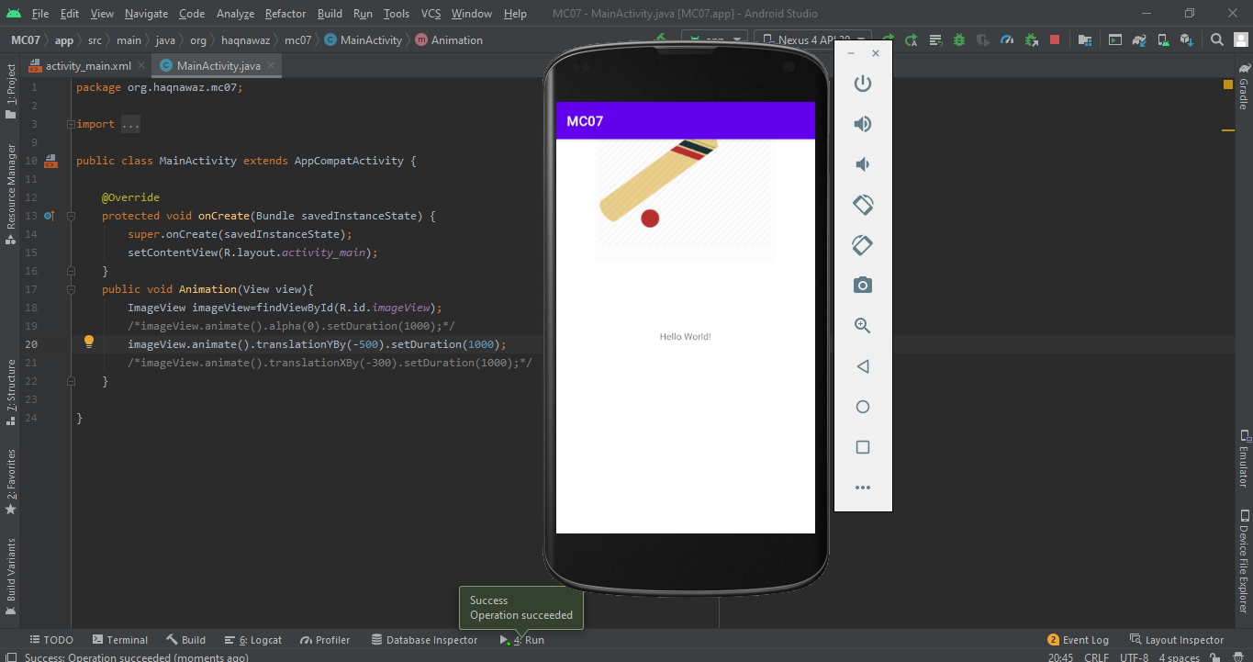

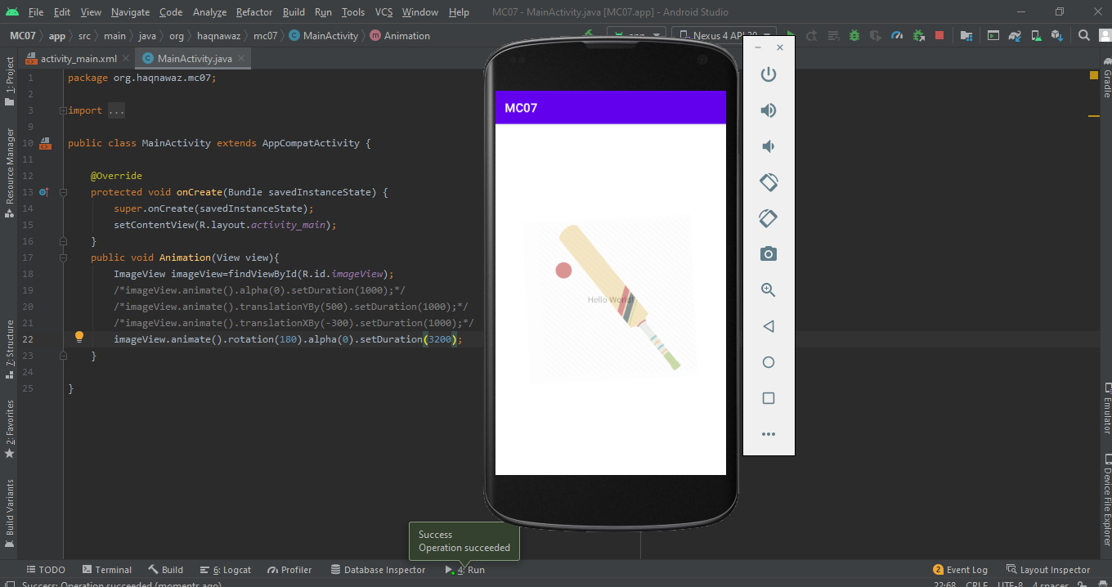

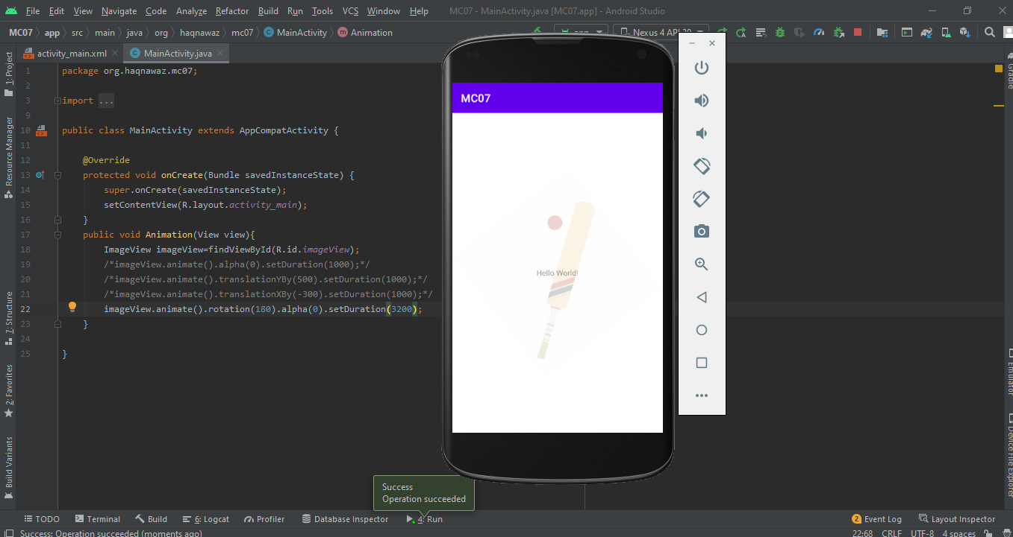

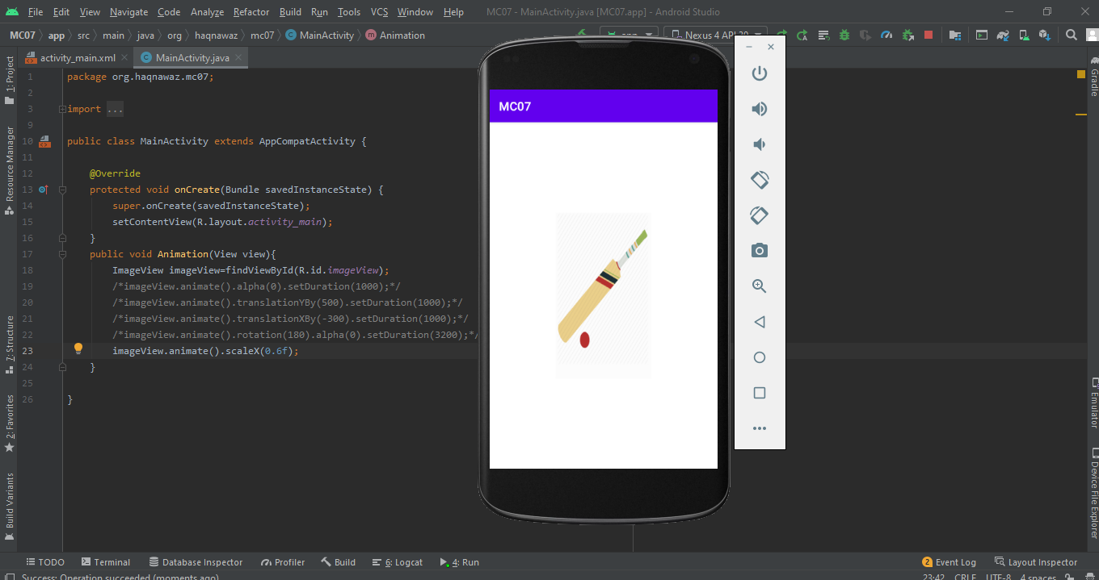

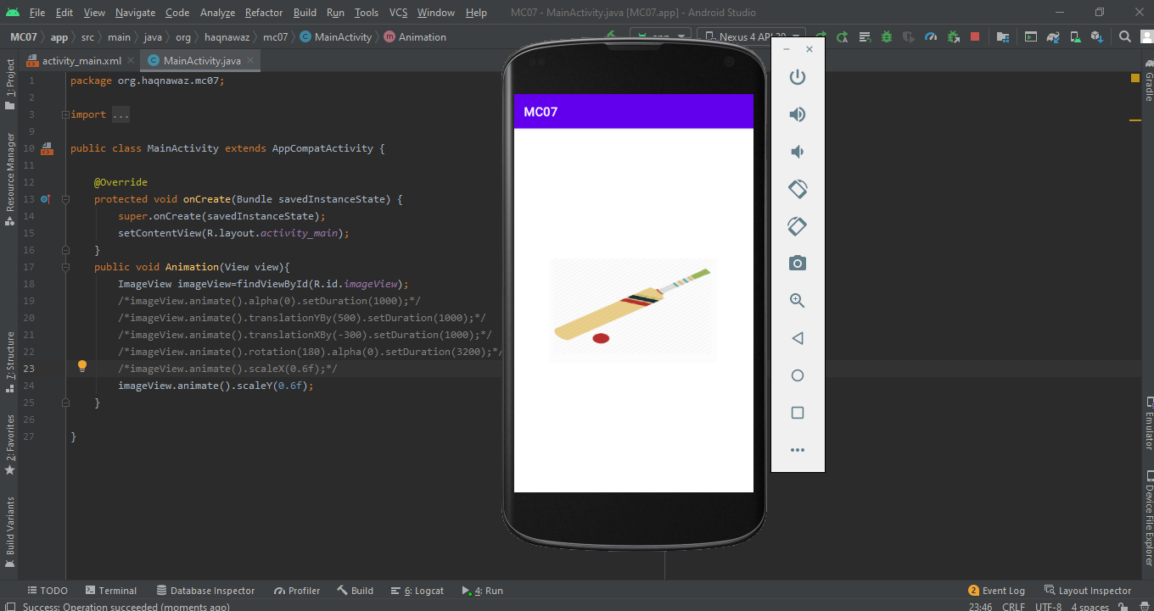

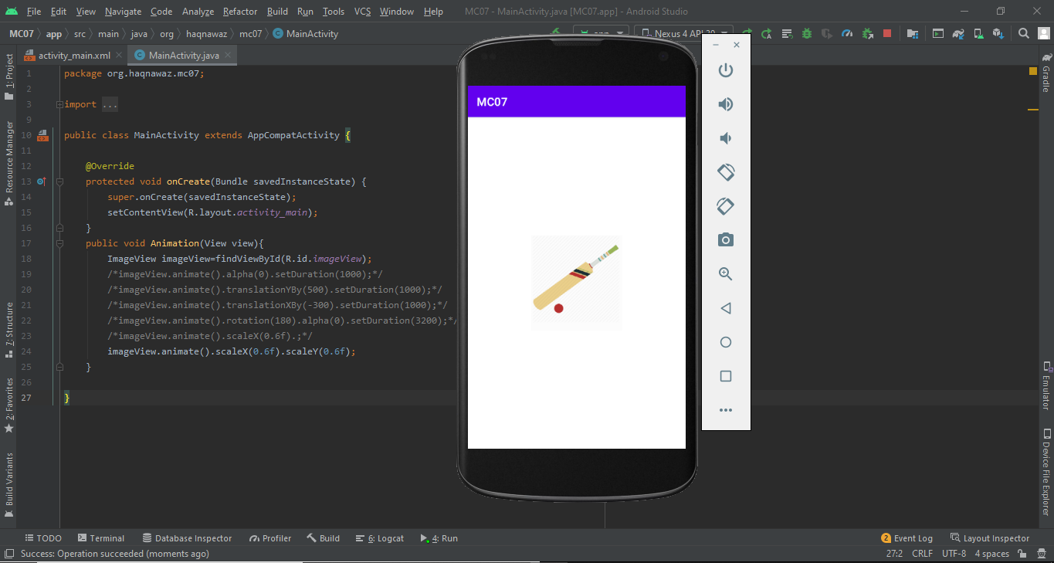

**Lecture 10-11: Database**

#### Step 1.2: Open Project in android studio.

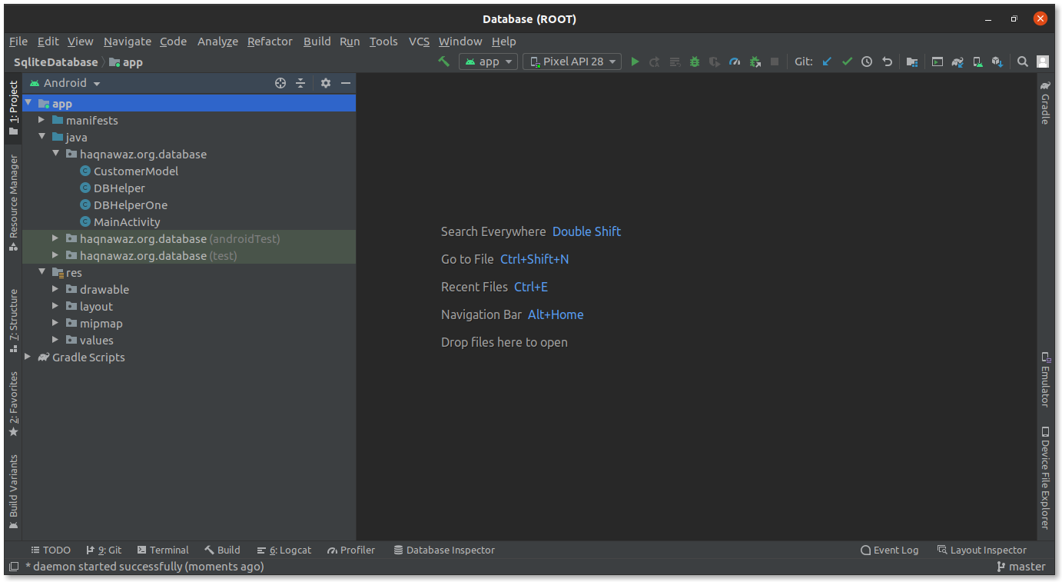

#### Step 1.3: Run the app.

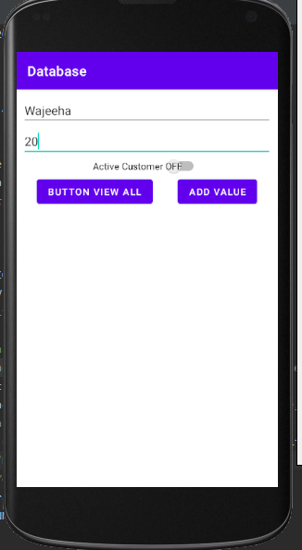

### Step 2: Implement getAllRecords.

#### Step 2.1: Add getAllRecords method in **DBHelper.**

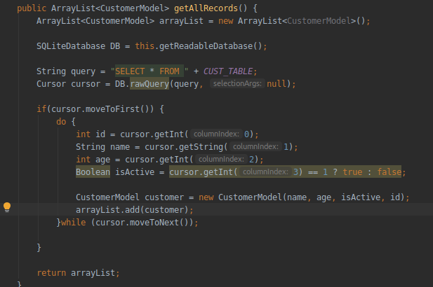

#### Step 2.2: Add ArrayAdapter.

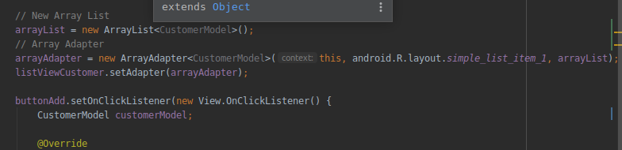

#### Step 2.3: Update buttonAdd onClickListener.

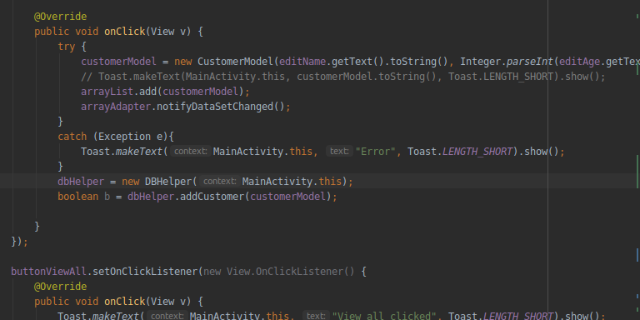

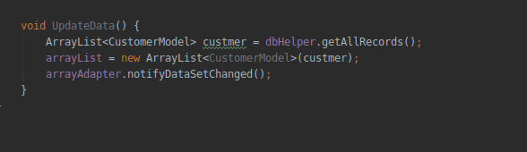

#### Step 2.4: Update buttonViewAll with following code.

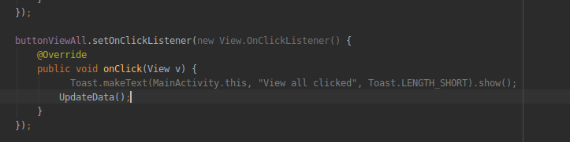

#### Step 2.5: Run and see the output.

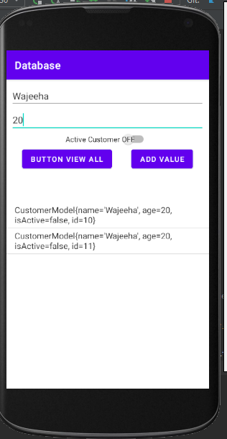

### Step 3 Implement Delete Functionality.

#### Step 3.1: Add delete method in **DBHelper.**

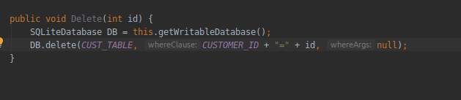

#### Step 3.2: On clicking listView delete the item.

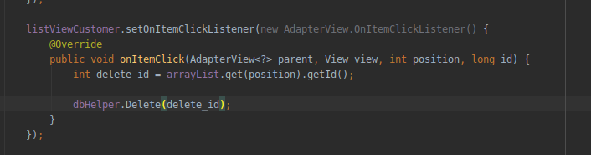

#### Step 3.3: Run the app and see if the app is working correctly.

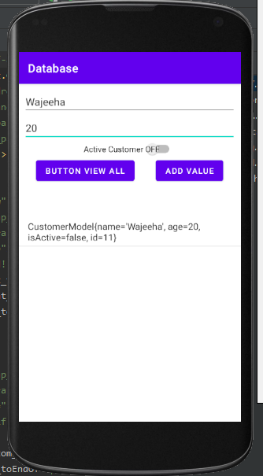

**Lecture 14: Dialogs**

#### Step 1.1: Create a new project.

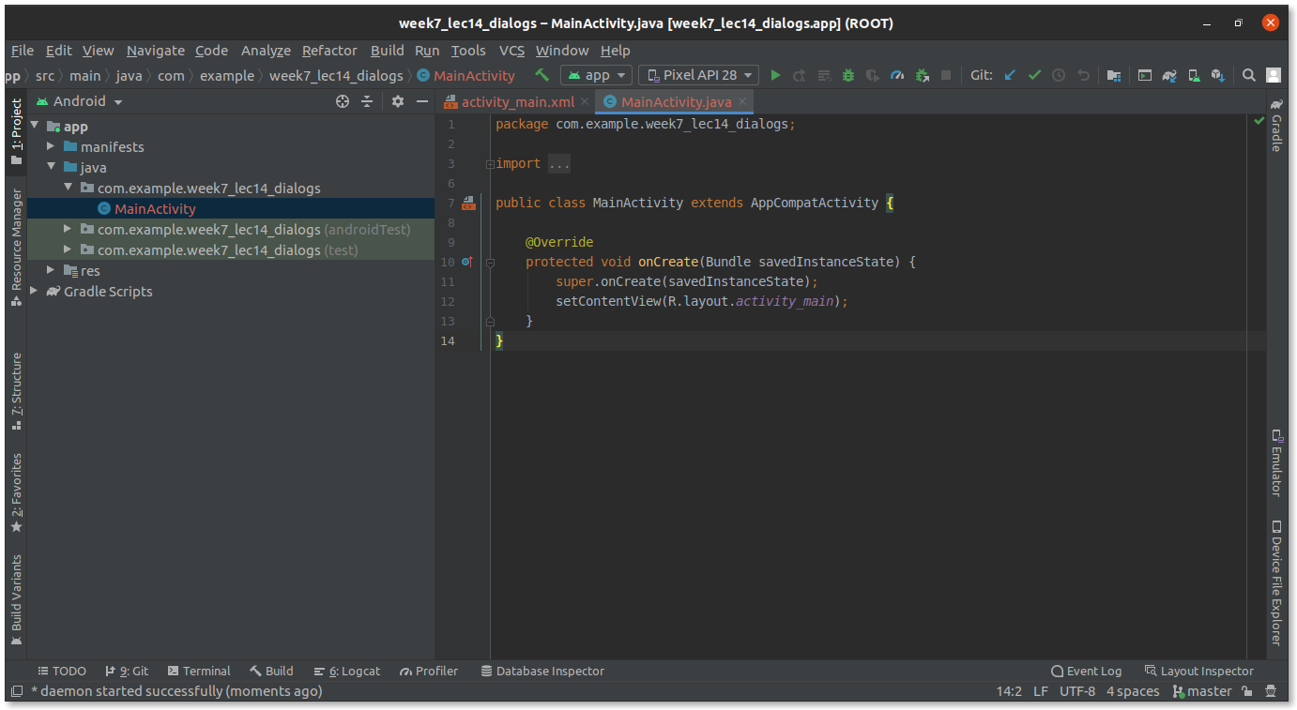

#### Step 1.2: Add a button **Open Dialog** and set its constraints.

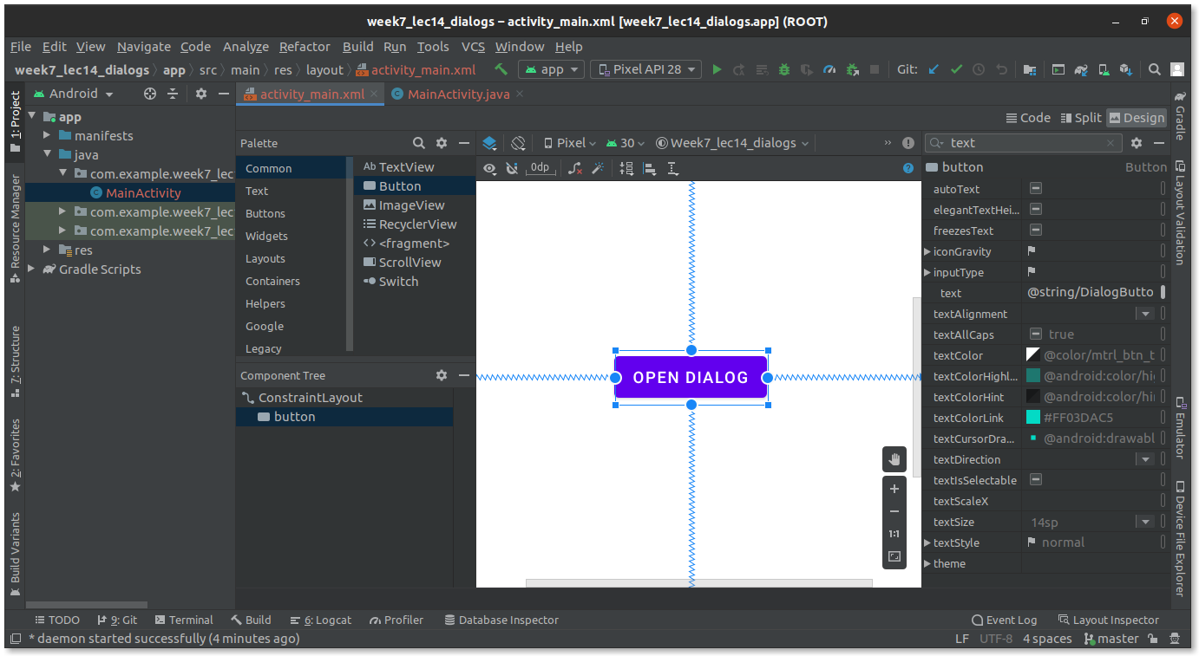

#### Step 1.3: Add onClick event handler.

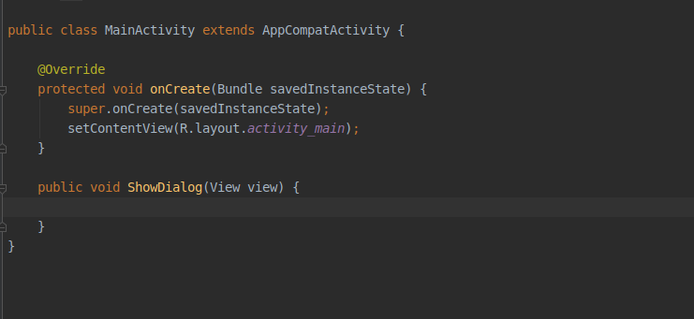

### Step 2: Complete Dialog Code.

#### Step 2.1: Create AlertDialog.Builder and Set Title and Message.

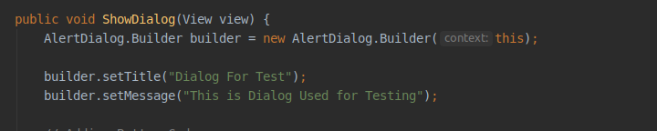

#### Step 2.2: Add positive and negative button code.

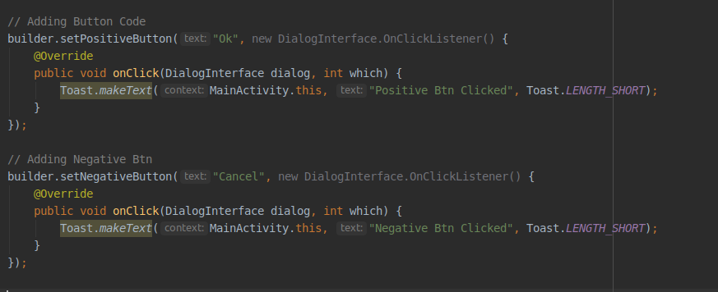

#### Step 2.3: Create AlertDialog and set Builder.

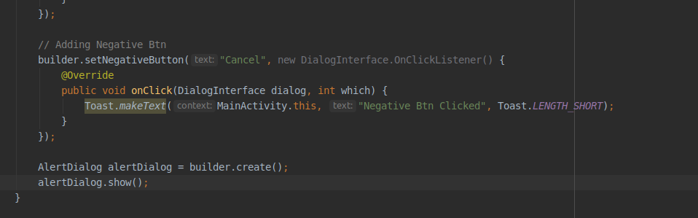

### Step 3: Test the App.

#### Step 3.1: Run the App.

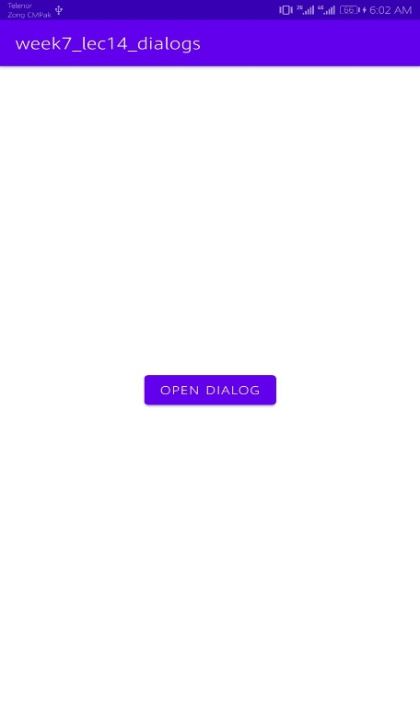

After clicking Open Dialog.

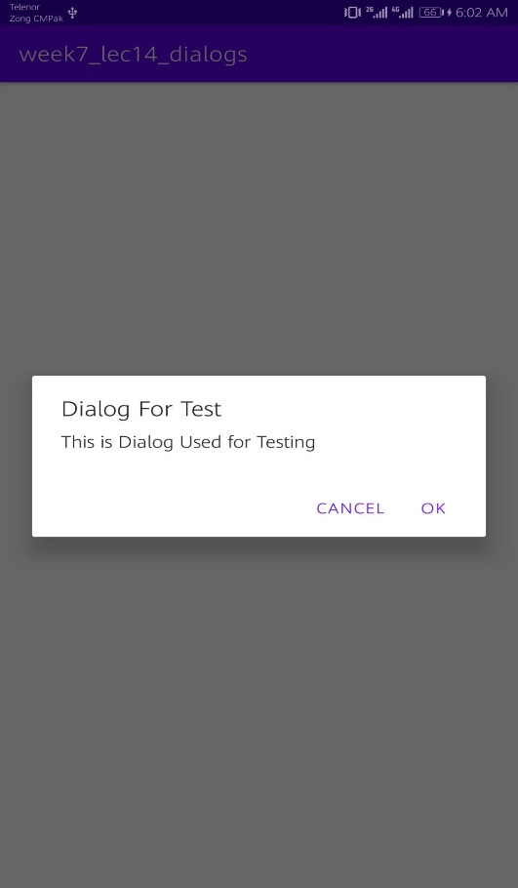

#### Step 3.2: Click on the “Ok” button.

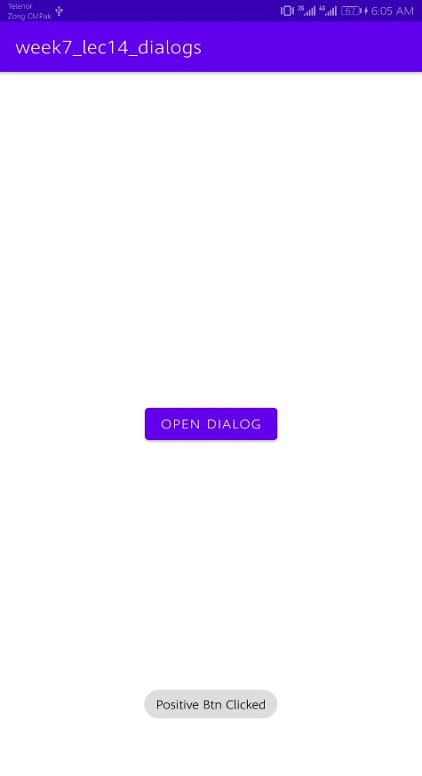

#### Step 3.3: Click on the “Cancel” button.

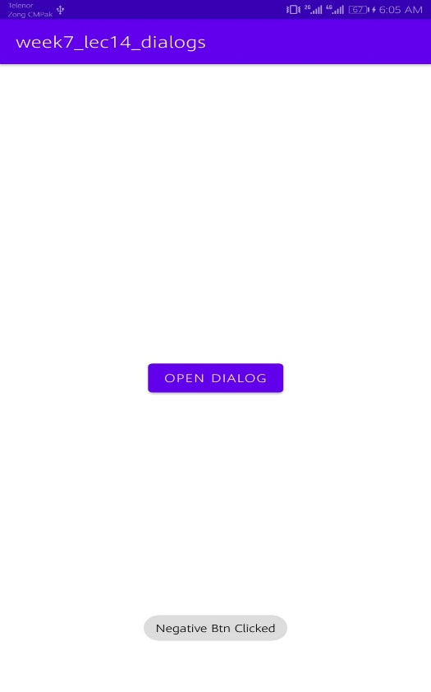

### Step 4: Add new Layout.

#### Step 4.1: Create new Layout.

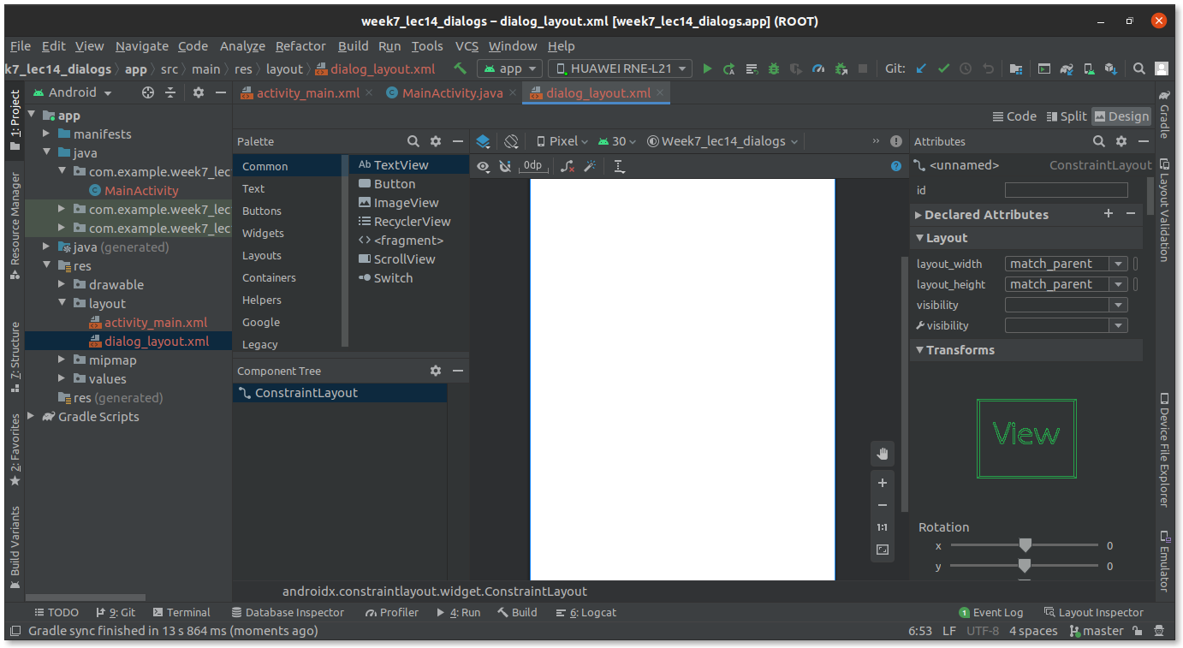

#### Step 4.2: Design UI of the Layout.

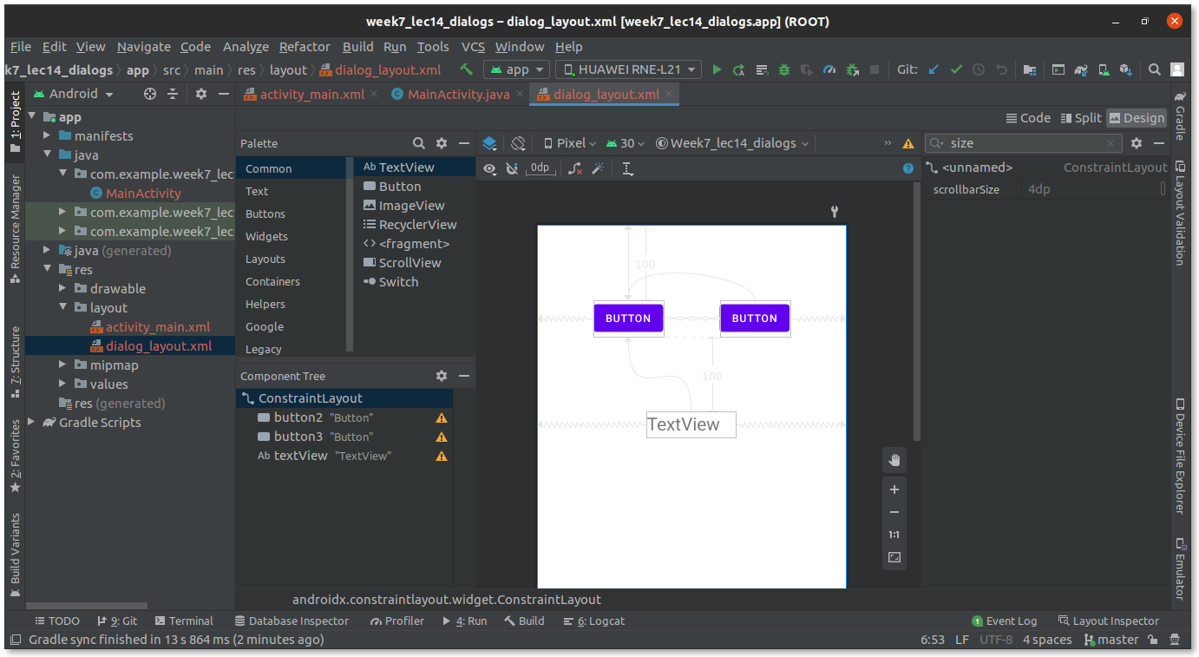

#### Step 4.3: Set layout in MainActivity.java.

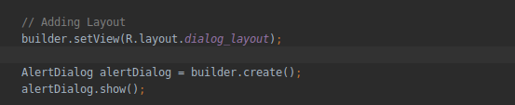

#### Step 4.4: Run the App.

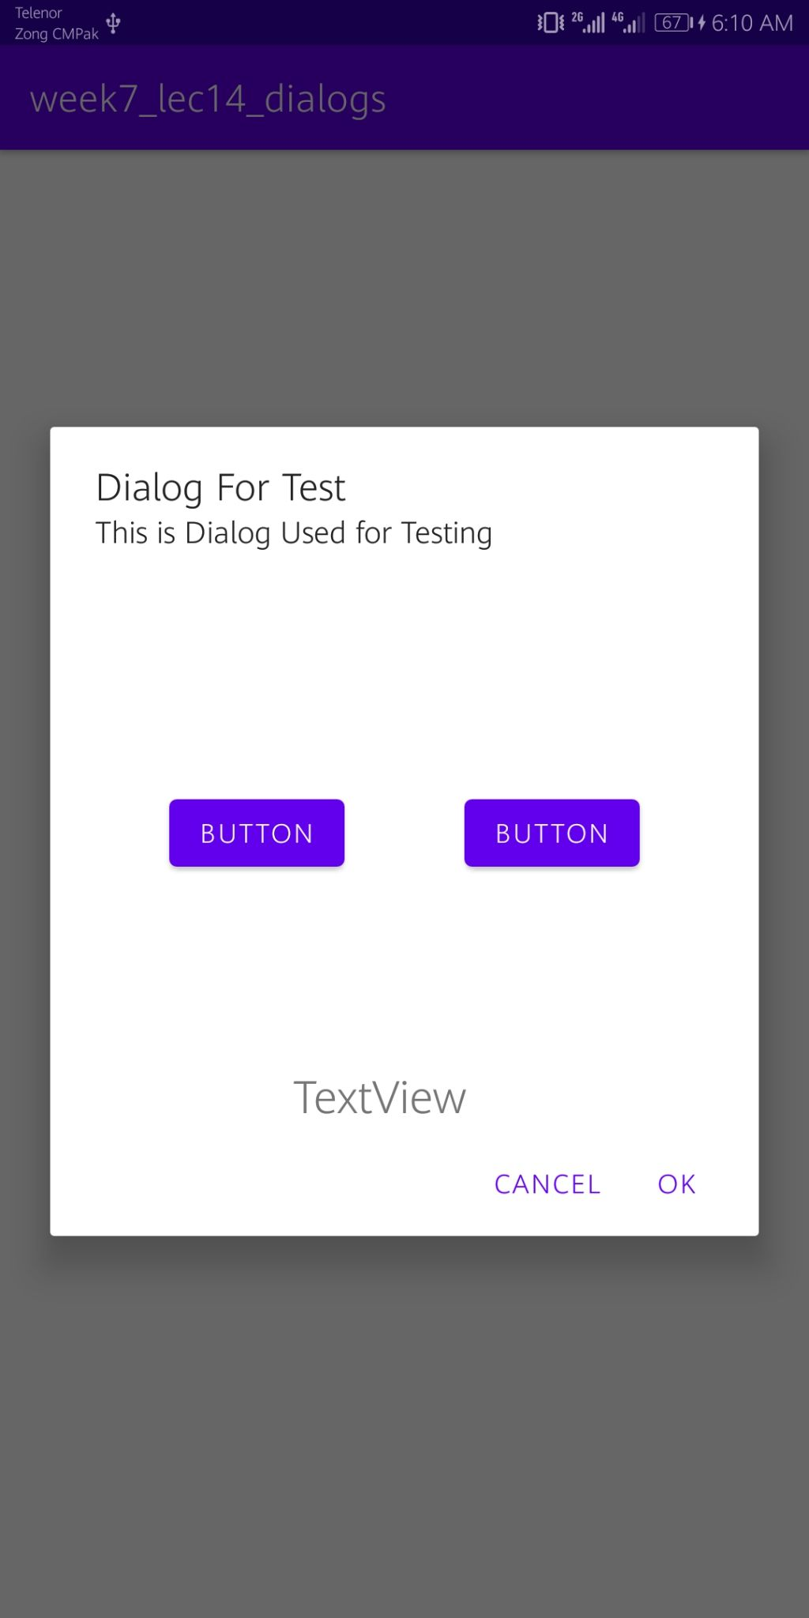

**Lecture 19: Fragments**

1. Create a project

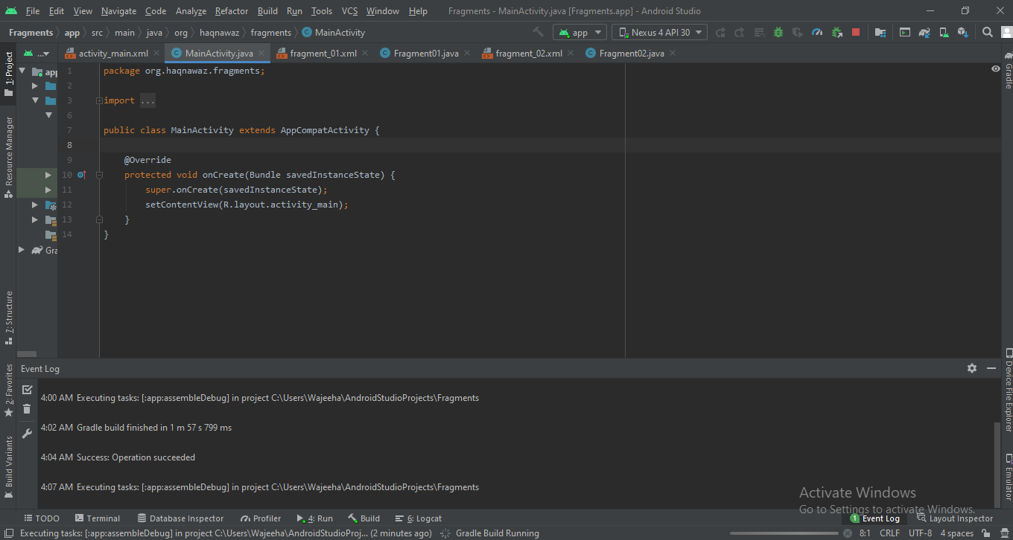

1. Place 2 buttons and a fragment in xml file

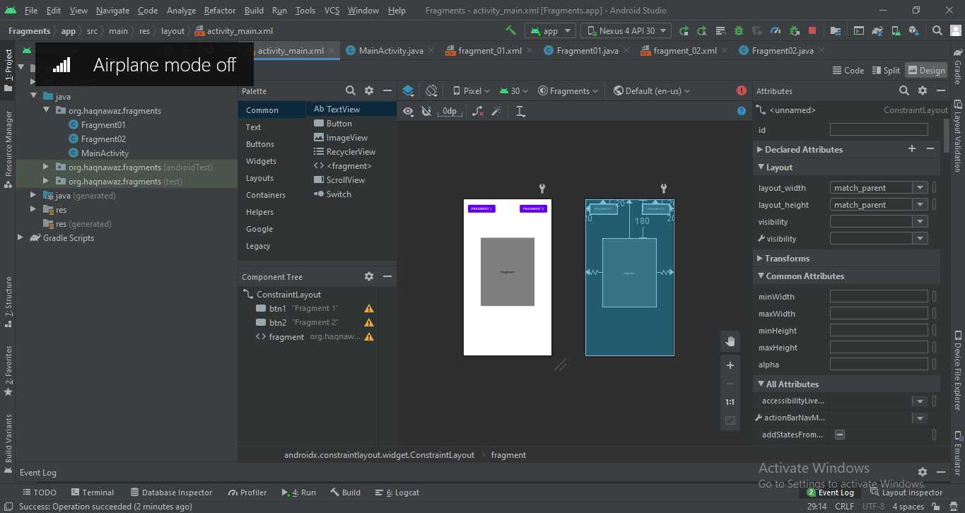

1. This will create an error . To solve this add fragmets as shown below

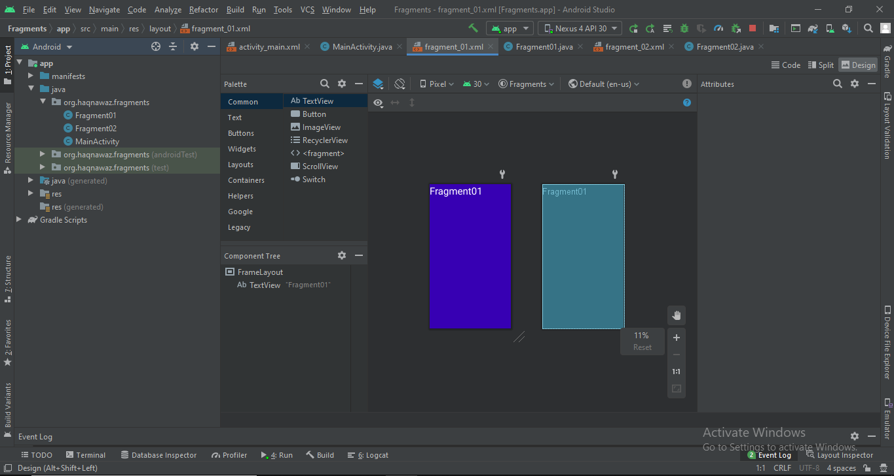 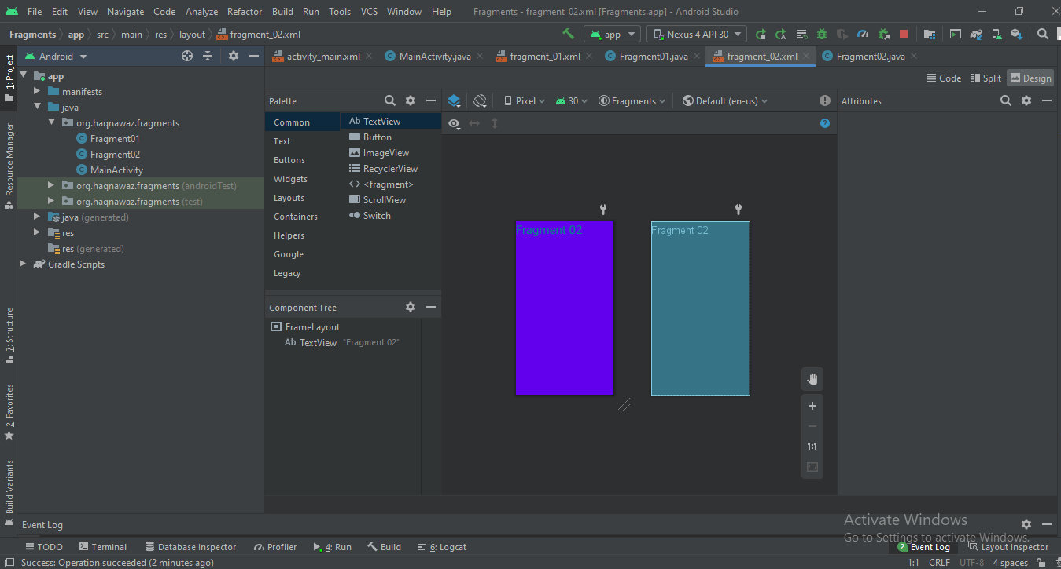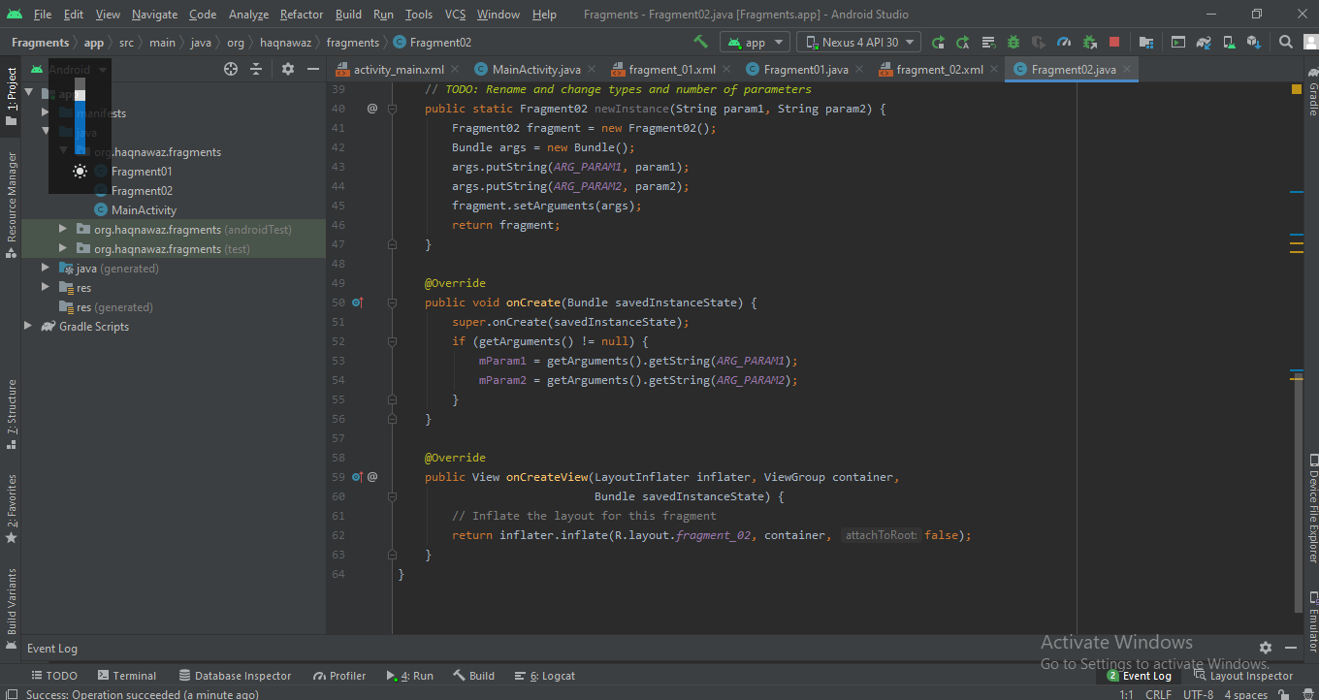

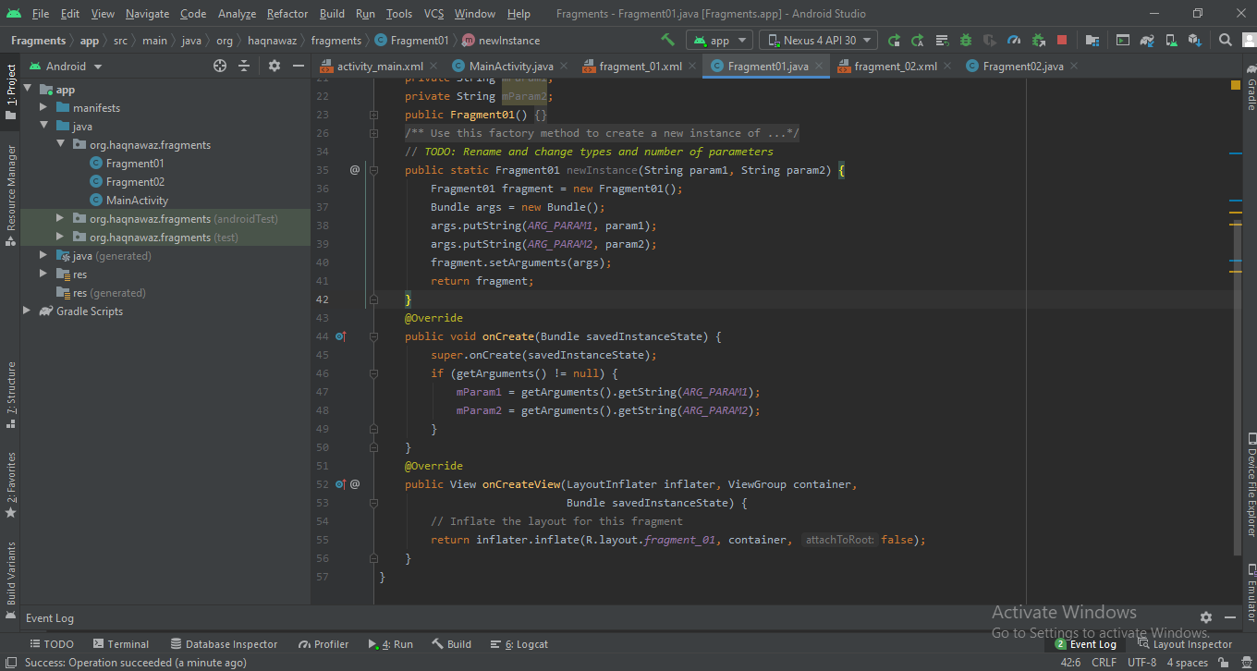

1. **Now run the application**

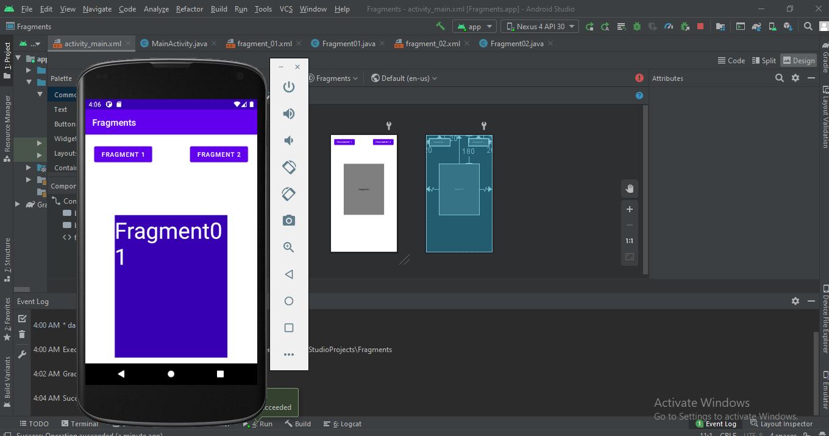

1. Lets replace the fragments by using transactionsal fragments as shown belo

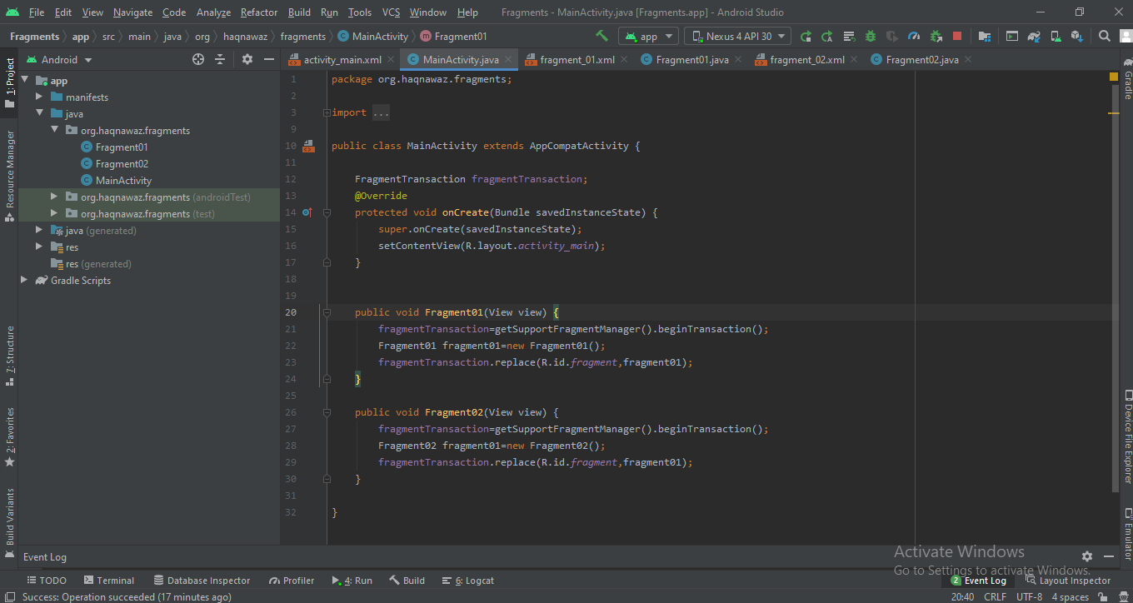

1. Now run the application

